***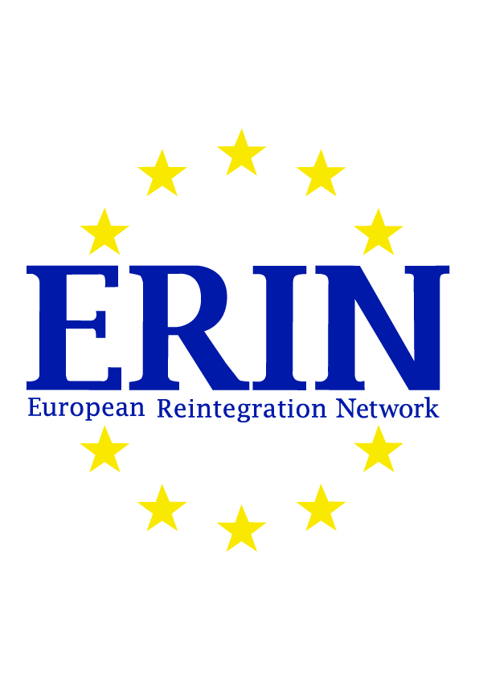*On the 25th of January 2017 a combined effort of 18 partner countries resulted in the publication of the European Reintegration Network (ERIN) Specific Action program - slow track tender. The ERIN Specific Action program – slow track offers socio-economic reintegration assistance in the form of counselling and referral and/or reintegration assistance to migrants who return voluntarily or non-voluntarily to their country of origin. This program is implemented by partner countries Australia, Austria, Belgium, Denmark, Finland, France, Germany, Greece, Italy, Luxembourg, Malta, Netherlands, Norway, Romania, Spain, Sweden, Switzerland and United Kingdom. ERIN Specific Action program – slow track is mainly funded by the European Commission via the European Asylum, Migration and Integration Fund (AMIF).**

Herein potential Service Providers (e.g. civil society organisations) are invited to show their interest for this European tender and submit a proposal. The goal of this European tender is to acquire service providers that deliver assistance in the form of information, counselling, referral and reintegration to returnees. It is essential to have a broad network regarding return and reintegration, as the aim is to enable foreign nationals to reintegrate and build up their life again after returning to their country.

The following countries of return are included in the European tender:

**Afghanistan**

**Bolivia**

**Ecuador**

**Honduras**

**Iran**

**Iraq (KRG)**

**Kenya**

**Libya**

**Morocco**

**Nepal**

**Nigeria**

**Pakistan**

**Russian Federation**

**Somalia (Federal, including Somaliland)**

**Sri Lanka**

**Zimbabwe**

All information and communication regarding the content and procedure of the ERIN Specific Action program tender takes place electronically, via C-Source, by Commerce-hub.

For more information and submitting questions and/or proposal, please follow the link to get to Commerce-Hub:

<https://portal.commerce-hub.com/index.cfm?action=sourcing:__requestform.subscribe&document=D9458676-9D6A-9CDE-9C6A474257A24979>https://portal.commerce-hub.com/index.cfm?action=sourcing:__requestform.subscribe&document=D9458676-9D6A-9CDE-9C6A474257A24979

The announcement can be found on:

<http://ted.europa.eu/udl?uri=TED:NOTICE:36283-2017:TEXT:NL:HTML&src=0&tabId=1>