EUROPEAN UNION - BASHKIMI EVROPIAN

DELEGATION TO ALBANIA
DELEGACIONI NE SHQIPERI

BID FORM
Public sale –DELALBT-2026-001
FURNITURE

Type and Model | APPOINTED ARMCHAIR/Visitor Chair
Year of production | 2015
Description | Wood chair, with leather coverage and metallic legs, comfortable chair.
Colour | Melon colour
Furniture status | In good condition
Other options/code | 01SE20151103358
The furniture was bought tax/custom free due to tax exemption of the EU Delegation to Albania under the Vienna Convention.

Information/Identification of the Bidder:
First/Last Name
ID Number
Address
e-mail
Phone number
OFFERED PRICE | EUR________________________

Date …………………. Signature…………………………………….

Please read the conditions for the public sale on page 2 of this document. With your bid and signature, you accept all conditions below.

Conditions of the public sale of the chair:

- Bid forms have to be duly filled in, signed, placed in a sealed envelope and have to be submitted to the EU Delegation premises with address - Rr. Papa Gjon Pali II, ABA Business Centre, 17th Floor, Tirana AL or by email at the address Delegation-Albania-Administration@eeas.europa.eu. Electronic bids have to be duly filled in, signed and sent in PDF format mentioning "Appointed Armchair Furniture (01SE20151103358) – Public Sale"– to the EU Delegation. Bids submitted differently will not be accepted.
- Bids will be accepted in EUR only.
- The information requested in the form must be complete and legible, otherwise the offer will not be accepted and will be automatically discarded.
- Deadline for submission of bids is Thursday 18/02/2026 at 16h30. Bids received after that time will not be taken into account.
- The offers will be opened and evaluated after the deadline for reception of bids.
- Once the deadline for submitting bids has expired, bids can no longer be withdrawn, and the winner is obliged to pay the price indicated in his/her offer and to withdraw the furniture from the place at the address - Rr. Papa Gjon Pali II, ABA Business Centre, 17th Floor, Tirana within the following 5 days.
- The furniture will be awarded to the bidder who presents the best offer.
- The result of the public sale will only be communicated to the winner of the auction.
- The successful bidder, before withdrawing the furniture, must provide evidence of the information filed in on page 1 of this document (by an identification documents) and of the payment/deposit at the EU Delegation’s bank account for the amount offered and accepted.
- The furniture is sold on an "as is, where is" basis, the Delegation is not responsible for any damage that may arise later.

Please find below stated the furniture photos (Melon armchair)

Photo Nr.1

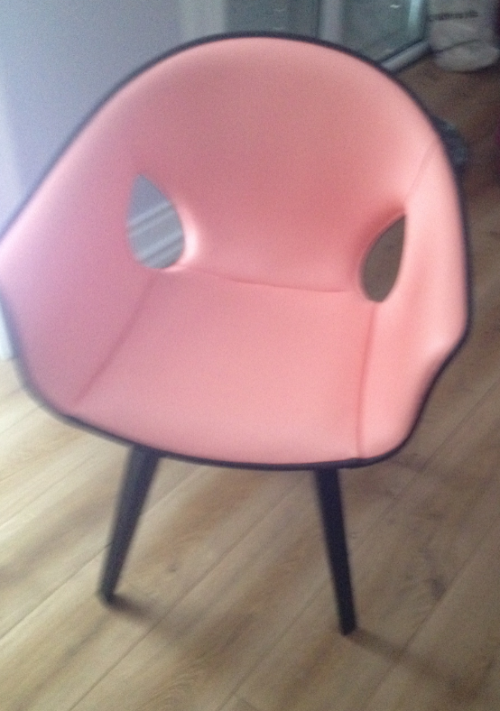

Photo Nr. 2

