In the context of the EU’s Global Gateway, the Regenerative Nature-Based Tourism Development programme aims to foster more regenerative and more competitive naturebased tourism activities with reduced inequalities and externalities.

Regenerative Nature-Based Tourism
Development

Management unit: based in Paris
€10 Million funded by the EU
€261 735 funded by the German government
Consortium Leader: EF
Partner: AICS and GIZ
Duration of 45 months
01/12/2025 – 31/08/2029
It is jointly co-funded by the European Union and the German government.

The programme is implemented by
- Expertise France (EF) in Colombia,
- Agenzia Italiana per la Cooperazione allo
Sviluppo (AICS) in Bosnia and Herzegovina
- Deutsche Gesellschaft für Internationale Zusammenarbeit (GIZ) in the Kavango Zambezi Transfrontier Conservation Area (KAZA TFCA).


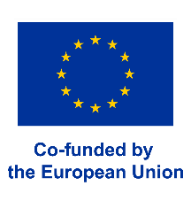
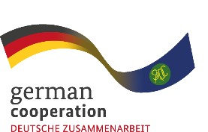

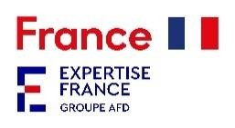

The project will support MSMEs of the nature-based tourism value chain through capacity building, financial support and market integration activities.

Regenerative Nature
-
Based Tourism Development

Fostering a greener, more regenerative and more competitive nature
-
based tourism value chain

It aims to design a robust methodology and generate knowledge by designing a global mechanism that can be replicated in other contexts to strengthen the regenerative nature-based tourism value chain.

Two main objectives:
To improve the long-term environmental and business performance of regenerative MSMEs in the tourism sector, particularly focusing on micro and small enterprises owned and operated by women, entrepreneurs or groups living adjacent to protected areas rich in biodiversity.
Implemented by

To strengthen the enabling business environment for regenerative MSMEs in the tourism sector, with reduced inequalities and enhanced integration into global nature-based tourism value chains.

