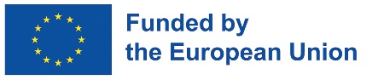
TA contract FACTSHEET

Title: Safe Digital Boost for Africa “SDBA” Coordination and Technical Assistance – SADC

EU contribution: € 1 099 380 (approx. BWP 17 million)
Period of implementation: 2025 to 2029
Location: Southern African Development Community
Implementing organisation(s): NTT DATA BELGIQUE
Objectives and description:
This contract seeks to accelerate EU-SADC cooperation and partnership under SDBA Action and its areas of interventions in line with the SADC Digital Transformation Strategy through targeted technical assistance.

The SADC SDBA initiative will be supported in its adequate formulation and preparation through coordination and consultation with relevant public and private stakeholders. Additionally, there will be enhanced coordination and collaboration of SADC SDBA component implementation with relevant SADC partners and private sector, SADC Member States as well as with other SDBA components and regional and bilateral programmes. Lastly, the SADC SDBA initiative will be adequately supported by advisory and technical assistance to EU Delegation to Botswana and SADC, the SADC Secretariat and other related organisations with focus on SDBA areas of implementation.

In that regard, Technical Assistance will be delivered to EU and SADC Secretariat by two experts (in Cybersecurity/e-Government Expert and e-Commerce/e-Payment) for respectively 542 and 506 days over the four years duration of the support. The experts work embedded within SADC Secretariat.

Incoming public / visibility events: -

Website / Social media account links:
N/A

