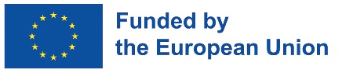
PROJECT FACTSHEET

Support to Job Creation and Investment Climate
EU contribution: € 5 million (approx. BWP 65 million)
Duration of implementation: 2021-2025
Location: Botswana, country wide
Implementing organisation(s): SOFRECO (lead), Deloitte and FCG
Project objectives and description: Targeting increased productive employment in Botswana, the Action caters for two areas, namely improving the ease of doing business, notably through supporting the development of e-Government services and the related digitalisation of processes; and the upgrade of the ecotourism value-chain. It will contribute to the objectives of the country’s Economic Recovery and Transformation Programme (ERTP) and the RESET Agenda. The project supports grants projects with Ecoexist and Impact Fund who work directly with local communities.

Achievements / expected results:
- Capacity developed to implement the ecotourism strategy with a focus on communities’ ability to participate in the sector development
- Strengthened architecture and enhanced roll-out of e-Government services for better and wider service delivery to support doing business
- Increased capability to design and implement reforms to facilitate Doing Business and to improve the investment climate

Incoming public / visibility events:

Project website / Social media account links:
- https://www.eeas.europa.eu/delegations/botswana/eu-support-job-creation-and-investment-climate-%E2%80%93-2020-2026_ru
- https://guardiansun.co.bw/news/p75-million-eu-programme-bolsters-job-creation-prospects/news
- https://www.facebook.com/euinbotswana/posts/the-job-creation-and-investment-climate-jcic-project-team-on-friday-12th-august-/1970552416477293/

