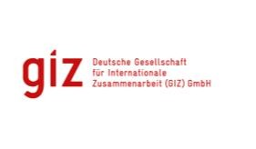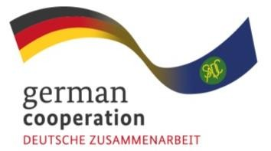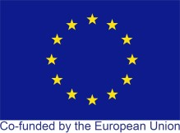
Published by:

Support to manufacturing of COVID-19-relevant medical and pharmaceutical products in the SADC region
Supported by Joint Action “Support towards Industrialization and the Productive Sectors (SIPS)”

Introduction
On 30 January 2020 the World Health Organisation (WHO) declared COVID-19 a disease of International Public Health Concern (IPHC). Subsequently in March 2020, the WHO declared the outbreak a pandemic leading to a number of countries declaring state of emergency in accordance with their national legislation. Since March 2020, the COVID-19 pandemic has posed unprecedented challenges in SADC’s health systems accompanied by increased health expenditure, disruption of global supply chains, threats to economic stability and the lives and livelihoods of people worldwide. To mitigate the pandemic spread, countries have opted for measures that require mandatory usage of medical products including masks and the continuous practice of hygiene principles with hand sanitizer and disinfectants. The treatment of infected people requires large quantities of hospital equipment and consumables such as ventilators, oxygen supply as well as personal protective equipment (PPE), including medical gowns, surgical scrubs, masks, and face shields among others. The demand for these COVID-19relevant medical and pharmaceutical products (CMPP) and consumables is expected to remain high in the Southern
Objective: | To enhance the private sector participation in regional COVID-19-relevant Medical and Pharmaceutical Products Value Chain
Financed by | SIPS is a joined action funded by the  European Union (EU) and by the Federal  Ministry for Economic Cooperation and  Development (BMZ)
Executing Agency | Deutsche Gesellschaft für Internationale  Zusammenarbeit GmbH (GIZ)
Duration | Oct 2019 – Feb 2023
African Development Community (SADC) region and represents a significant challenge for those countries with limited production capacity and high dependence on imports. The global supply chain disruption caused by the pandemic and the concomitant trade bans imposed by producer countries has worsened access to consumables, pharmaceutical products, and medical equipment in the SADC member states. This, in turn has compromised the delivery of health services and threatened the effectiveness of the measures preventing the virus transmission.

Background
SADC is currently implementing the Regional Indicative Strategic Development Plan (RISDP) 2020 – 2030. One of the priorities of RISDP is to enhance SADC’s regional integration agenda through enhanced industrialisation. In this regard SADC aims at improving its value chains including those related to manufacturing of medical supplies and pharmaceuticals. The Cooperation for the Enhancement of SADC Regional Economic Integration (CESARE) Project is aimed to support SADC’s efforts in this area. Under European Union and the German Ministry for Economic Cooperation and Development (BMZ) financing, the Joint Action SIPS, which is part or the CESARE Project, aims to enhance private sector participation in the regional medical and pharmaceutical value chains to establish and/ or scale up the manufacturing of high-quality and affordable COVID-19relevant medical and pharmaceutical products. This aims to increase regional production capacity, boost regional competitive advantage, strengthen regional value chains and reduce dependence on imports.

Approach
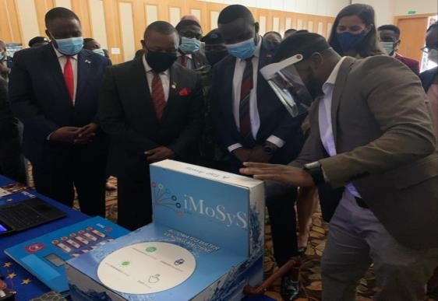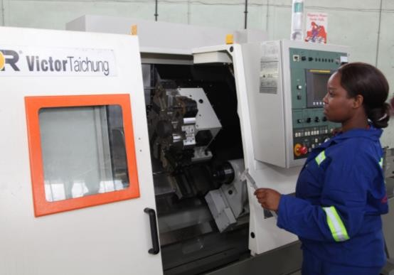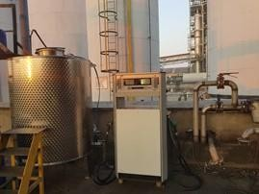

Photos: Top left © iMoSyS; middle © GIZ / Harare Institute of Technology: right© EthCo; bottom left© Archemics, middle ©SMM; right© Cally Clothing
The Joint Action SIPS is supporting for-profit companies as well as non-profit institutions in the SADC region to increase

industrial capacity, ensure manufacturers’ production continuity during the pandemic and enhance the production capacity of innovative projects.
In early 2020, an assessment was undertaken to identify CMPP needs, production capacity in the SADC region as well as the main players and stakeholders. Subsequently, the Joint Action SIPS published a call for proposals for innovative projects aimed at increasing the production of locally manufactured CMPP in the SADC region. The call was advertised on various social media platforms, websites and regional newspapers in the three official SADC languages. The Joint Action conducted a careful selection of the candidates, based on the proposals’ relevance, innovative aspects, and the companies’ capacity to scale up production.

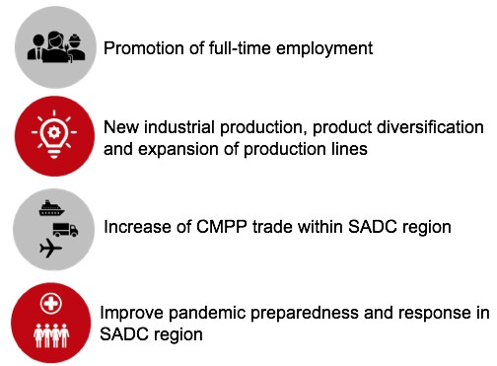

Estimated Impact
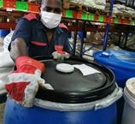
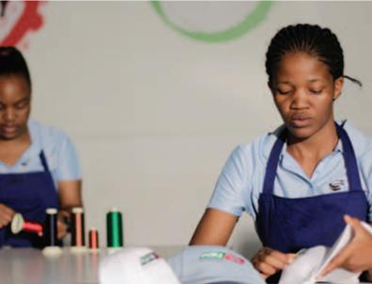
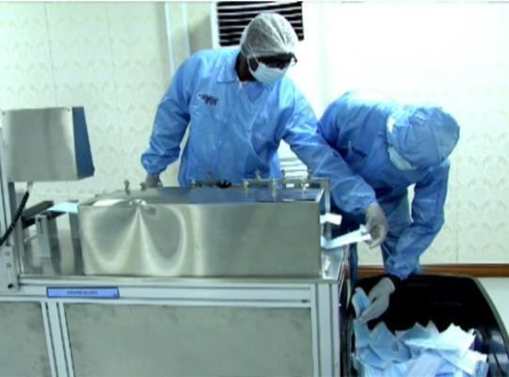
To date, 14 applicants (private sector companies, a stateowned company and universities) of 7 SADC Member States are benefiting from SIPS CMPP. The beneficiaries can be divided in three CMPP focus areas namely: (i) PPE, including face masks, face shields, medical gowns; (ii) hand sanitizers and hospital disinfectants; and (iii) hospital equipment including ventilators. The grants will finance required machinery, raw materials, consulting, and training costs of innovative manufacturing projects.
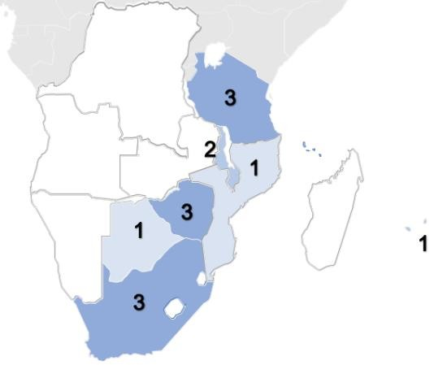

Grant Distribution in the SADC region

SIPS CMPP is expected to foster self-reliant economies, decrease import dependency, build regional resilience to future disease outbreaks, strengthen healthcare service delivery, and improve local public health outcomes. Most importantly, improved access to CMPP will enhance the measures taken by the governments to curb COVID-19 transmission and support socio-economic recovery in the region.

Published by Deutsche Gesellschaft für Internationale Zusammenarbeit (GIZ) GmbH.
Registered offices Bonn and Eschborn, Germany
CESARE/SIPS Programme Private Bag X12 (Village) Gaborone, Botswana: jan.peter.boettcher@giz.de www.giz.de/en/
On behalf of Federal Ministry for Economic Cooperation and Development (BMZ)
Addresses of the BMZ offices
BMZ Bonn Dahlmannstraße 4 53113 Bonn, Germany T +49 (0)228 99 535-0 F +49 (0)228 99 535-3500
BMZ Berlin Stresemannstraße 94 10963 Berlin, Germany T +49 (0)30 18 535-0 F +49 (0)30 18 535-2501
poststelle@bmz.bund.de
www.bmz.de

This document was produced with the financial assistance of the European Union (EU) and the German Federal Ministry for Economic Cooperation and Development (BMZ). The content and views expressed herein can in no way be taken to reflect the official views of the EU or BMZ. The programme management team of the Deutsche Gesellschaft für Internationale Zusammenarbeit (GIZ) GmbH is responsible for the content of this document.

