Ambition by 2030: Integrate the African and European multimodal transport networks in line with the regional and continental frameworks and tailor these networks to the economic potential of the African Continental Free Trade Area.
In the context of the 6th EU-AU Summit, Team Europe proposes to support quality connectivity infrastructure for smart, fair and affordable mobility and trade within Africa and in between Africa and Europe.
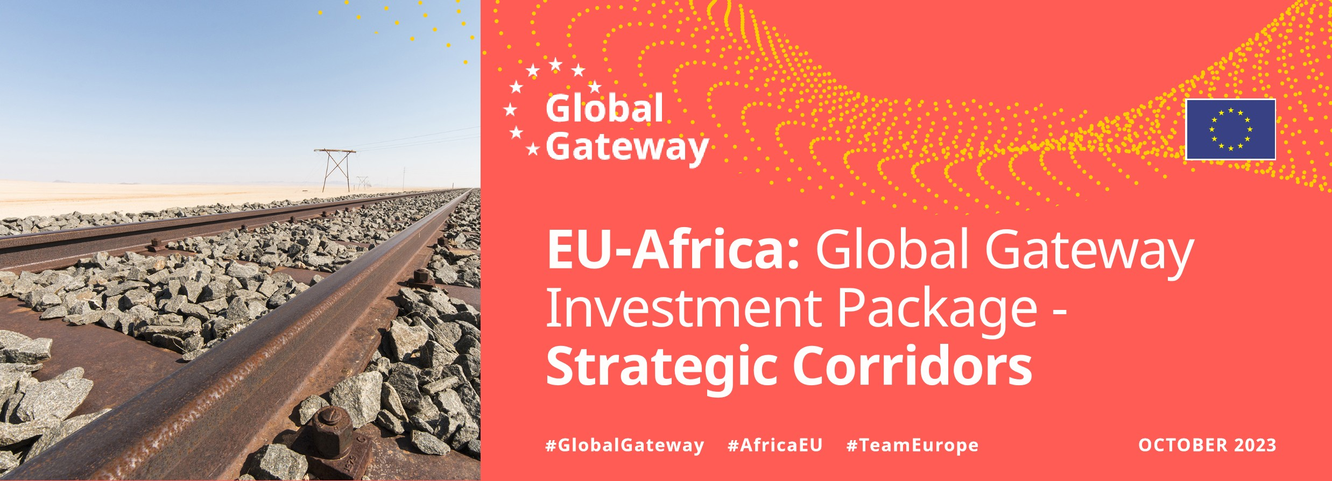
The Global Gateway Africa-Europe Investment Package supports the creation of strategic, sustainable and secure transport corridors and support value chains, services and jobs that can benefit industries in both Africa and Europe.
The Strategic Corridors underpin the territorial organisation - rural and urban - through reliable networks and services.
The investment package develops multi-country infrastructure by supporting investment in sustainable, efficient, and safe connectivity between both continents and updating and harmonising regulatory frameworks.

1. ABIDJAN-LAGOS
West Africa: Côte d’Ivoire, Ghana, Togo, Benin,
Nigeria
2. ABIDJAN-OUAGADOUGOU
West Africa: Côte d’Ivoire, Burkina Faso

3. PRAIA / DAKAR-ABIDJAN
West Africa: Senegal, Gambia, Guinea-Bissau, Guinea, Sierra Leone, Liberia, Côte d’Ivoire, Cabo Verde.
Built in Cabo Verde (Praia/Dakar-Abidjan Strategic Corridor): in collaboration with the African Development Bank on a blended financial operation of €38.1 million including €17 million EU grant.
Built in Liberia (Praia/Dakar-Abidjan Strategic
Corridor): in collaboration with European and African Development Bank on a blended financial operation of €53.8 million including €20.2 million EU grant.

4. COTONOU-NIAMEY
West Africa: Benin, Niger

5. LIBREVILLE / KRIBI / DOUALA-N’DJAMENA
Central Africa: Gabon, Equatorial Guinea,
Cameroon, Chad, São Tomé and Príncipe.
Built in Chad (Libreville/Kibri/Douala-N’Djamena Strategic Corridor): in collaboration with
European Development Bank and World Bank on a blended financial scheme of €275 million including €35 million of EU grant. Built in Cameroon (Libreville/Kibri/DoualaN’Djamena Corridor): in collaboration with European Development Bank and French Development Agency (AFD) on a blended financial scheme of €243 million including €23.6 million of EU grant (railway).

6. DOUALA / KRIBI-KAMPALA
Central Africa: Cameroon, Central African
Republic, Democratic Republic of the Congo, Uganda
7. DAR ES SALAAM-NAIROBI-ADDIS

ABABA-BERBERA / DJIBOUTI
East Africa: Tanzania, Kenya, Ethiopia,
Somalia, Djibouti

8. MOMBASA-KISANGANI
East Africa: Kenya, Uganda, Rwanda, Democratic Republic of the Congo. A TEI initiative exists (France and Germany) in collaboration with EIB (including €44 million of EU grant).
Built in Uganda (Mombasa-Kisangani Strategic Corridor): €229.5 million project involving
French Development Agency (AFD), the African Development Bank and a €91 million EU contribution.

9. MAPUTO-GABORONE-WALVIS BAY
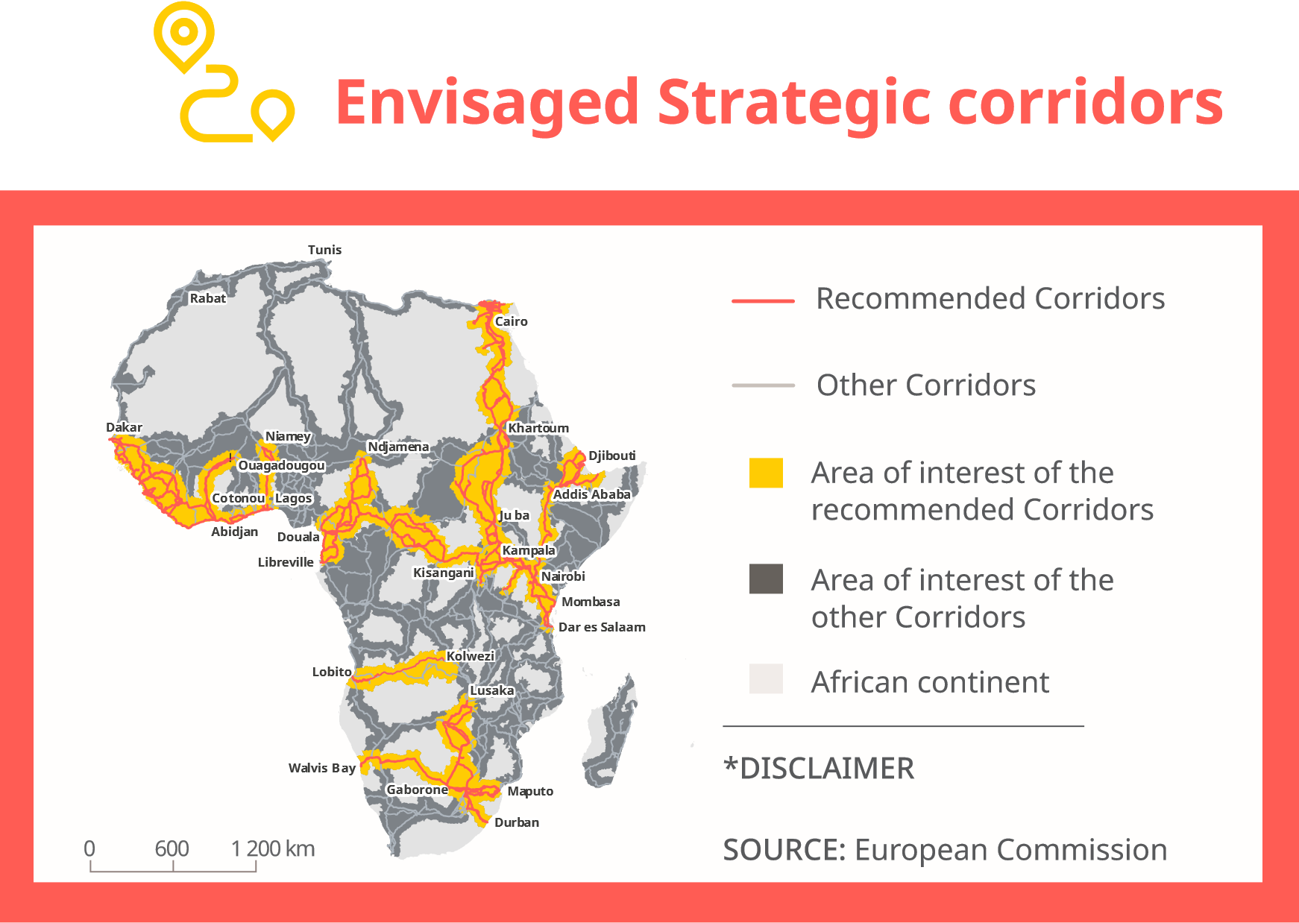
Southern Africa: Mozambique,
South Africa, Eswatini, Botswana, Namibia

10. DURBAN-LUSAKA
Southern Africa: South Africa, Botswana, Zimbabwe, Zambia

11. CAIRO-KHARTOUM-JUBA-KAMPALA
North and East Africa: Egypt, Soudan, South Sudan, Uganda

12. LOBITO-KOLWEZI-LUBUMBASHI / SOLWEZINDOLA-LUSAKA
Central and Southern Africa: Angola, Democratic Republic of the Congo, Zambia
* This map and the content therein do not necessarily represent the official position of the European Commission or of the European Union. It is to be considered as an internal working document for study purposes.

In focus examples:
Strategic Corridor PRAIA / DAKAR-ABIDJAN
CABO VERDE:
The expansion and modernisation of the port of Ingles in Maio and of the port of Palmeira in Sal will increase capacity, accessibility and physical resilience of the infrastructure. It is the result of a blended financial operation of €38.1 million with the African Development Bank, with a EU grant of €17 million.
LIBERIA:

The rehabilitation Mano River Union Road will result in the paving of the Sanniquellie to Loguatuo Road section (47.1 km) and the construction of a one-stop border post at the Loguatuo / Gbeunta/Danane border between Liberia and Côte d’Ivoire. As well as reducing transport costs, better road conditions will facilitate the free movement of people and goods, increase road safety and facilitate the development of agriculture. The project, to be completed in June 2024, will generate approximately 400 direct temporary jobs during the construction phase and 100 permanent jobs for operations and maintenance.
This action will result from a €53.8 million blended financial operation with the EIB and the African Development Bank, including an EU grant of €20.2 million.
In focus examples:
Strategic Corridor MOMBASA-KISANGANI
KENYA:
The EU and Kenya inaugurated the first section of an upgraded 560km highway along the Northern corridor, East Africa’s busiest trade and transport route. The first section of the Mombasa-Kilifi highway will increase the route’s vehicle capacity, greatly improve regional connectivity, and enhance accessibility for rural and urban areas. We support the development of green electric mobility such as the operation of the first public green electric BRT system in Sub-Saharan Africa.
The EU has supported this section of the Northern Corridor with €30 million in grants.
The four-stage project of the Northern Corridor between Mombasa and Kilifi brings the total Team Europe support of the project to €275 million.

In focus examples:
Strategic corridor LIBREVILLE / KRIBI / DOUALA-N’DJAMENA
CHAD:
The rehabilitation of a 596km road between N’djamena, Koutere and Moundou is one the main components of the support to the strategic corridor between Douala and N’Djamena. It is the main supply route for Chad, which has no coastline. This action, which will result from a €275 million blending operation with the EIB and the World Bank (including a EU grant of €35 million), will facilitate trade and economic integration.
Since the launch of the EU-Africa Global Gateway Investment Package, eleven strategic corridors aligned with the African Union’s second priority action plan have been identified for an enhanced and greener EU-Africa connectivity.
These corridors will facilitate trade and mobility within Africa as well as between Africa and Europe, and they will support investment in sustainable, efficient and safe connectivity between the continents, thereby developing new value chains that benefit industries both in Africa and Europe.


In the area of transport, the EU will focus the bulk of its support to the strategic corridors, as agreed with the African partners. A number of concrete actions have been launched, as exemplified by the focus examples.
© European Union, 2023
Reuse of this document is allowed, provided appropriate credit is given and any changes are indicated
(
Creative Commons Attribution 4.0 International license). For any use or reproduction of elements that are not
owned by the EU, permission may need to be sought directly from the respective right holders.

All images © European Union, unless otherwise stated.
Progress is ongoing: On the margins of the G20 in India in September 2023, the EU and the USA announced their intentions to work jointly with partners in Angola, the Democratic Republic of Congo and Zambia on the development of a new strategic corridor, the Lobito Corridor, connecting the Lobito port in Angola with the Katanga province in the Democratic Republic of Congo and the Copperbelt in Zambia to upgrade critical infrastructure and unlock the enormous potential of this region.

