Implementing organisation(s) | Mountain Societies Development Support Programme Foundation
Duration | July 2018 – June 2021
Project budget | Total budget - € 690,869  EU contribution - € 621,299
Project partners | Public Foundation Camp Ala-Too
Location | Kyrgyzstan, Leilek district and Batken region
Keywords | Rural population, farming households, sustainable farming, Kyrgyzstan.

Program Development Objective
The project aims to promote sustainable and inclusive development in rural areas of Leilek and Batken districts through increased participation of local community based organizations in local development.

Main target groups
300 targeted farming households (at least 70% will be women-led households) running multi-product model of sustainable farming based on agroecology and energy efficiency. On the basis of average family size of six, the total direct beneficiaries will be around 1800 inhabitants.
Key challenges that the program helps to address:
- Low income and employment rate among women-led households and small-scale farmers of remote rural districts;
- Poor infrastructure and a degraded environment due to the lack of natural resources management;
- Vulnerable livelihoods due to energy deprivation;
- Weak local governance that reinforces poverty.

Expected outcomes
- Local community based organizations (CBOs) and supporting local authorities (LAs) are strengthened to effectively promote local development processes and jointly contribute to the socio-economic development within the targeted region;
- CBOs and LAs from the targeted villages improved their capacities to successfully implement village-level socio-economic development projects under Component 2 through joint and collaborative development activities.
- Livelihoods of people living in targeted rural communities improved through increased incomes for poor rural dwellers and improved access to village-level economic infrastructure and social services

Implementation status: Ongoing

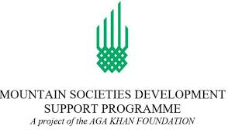
Website | - www.akdn.org

