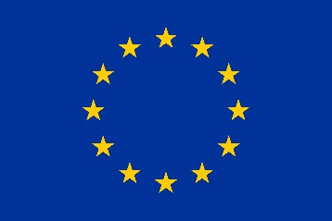
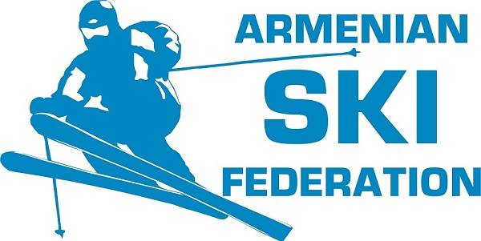

This project funded by
The Europe Union

Formal opening of Ashotsk Ski Centre
January 26, 2019
13.00-14.00

13:00-13.20: Welcome and inauguration ceremony

Welcome by Alexandru Coica, ALDA followed by inauguration remarks by:

- Mr. Artur Harutyunyan, President, Armenian Ski Federation
- H.E. Mr. Piotr Antoni Świtalski, Ambassador, Head of EU Delegation
- Mr. Vache Terteryan, First Deputy Minister, RA Ministry of Territorial Administration and Development
- Mr. Karen Manukyan, Acting Mayor of Ashotsk Village

13.20-13:25: Ribbon cutting

- H.E. Mr. Piotr Antoni Świtalski, Ambassador, Head of EU Delegation
- Mr. Gagik Sargsyan, Vice President, Armenian Ski Federation
- Mr. Karen Manukyan, Acting Mayor of Ashotsk Village
- Mr. Mikael Mikaelyan, Armenian professional/competitive skier
- Young female Ashotsk skier

13.30-13.45: Tour of the Ashotsk Ski Center

- Ms. Dzovag Mandjikian, DZ Architectural Design Studio
- Mr. Ashot Margaryan, Shelter Construction
- Mr. Arthur Mikaelyan, Ashotsk Ski Centre manager

13:45-14:00: Refreshments and Q&A opportunity for media

*Simultaneous interpretation will be provided during the event
** Media is invited to cover the event and participate in the Q&A session

