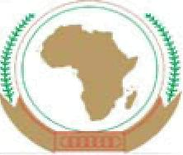
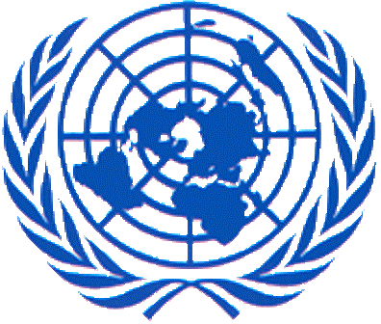
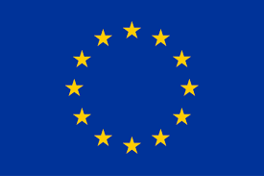

Third African Union-European Union-United Nations Trilateral Meeting
New York 23 September 2018
Joint Communiqué

- The Chairperson of the African Union Commission Moussa Faki Mahamat, the President of the European Commission Jean-Claude Juncker and the Secretary-General of the United Nations António Guterres, met on 23 September 2018 at United Nations Headquarters in New York in the margins of the United Nations General Assembly. They were accompanied by senior officials from the three organisations, including Vice President/High Representative Federica Mogherini, Commissioner for Peace and Security Smail Chergui, Commissioner for Political Affairs Minata Samate Cessouma and Deputy Secretary-General Amina J. Mohammed. They discussed the ongoing cooperation between the three organisations and ways to better coordinate efforts in addressing global challenges. They concurred that peace, security and stability are paramount not only to ensure decent living conditions for all citizens, but also to attract investments necessary for sustainable and inclusive growth.

- The leaders reaffirmed their joint commitment to promote an effective multilateral system and expressed their readiness to take further action towards reinforcing synergies and coordination in tackling global challenges through international cooperation. They underscored the positive developments noted in several areas, including the increasing economic integration in Africa and the solid steps taken by the African Union towards self-reliance. Building on this positive momentum of the innovative trilateral cooperation, the AU, EU and UN intend to increase their coordination and cooperation at political, economic and operational levels on a range of issues notably in the area of peace and security, including conflict prevention and mediation; implementing the 2030 Agenda for Sustainable Development and the African Union's Agenda 2063; inclusive and sustainable growth, human rights and climate change, as well as support to the implementation of AU and UN reforms.

- They welcomed the cooperation and the results achieved by the AU-EU-UN Taskforce to address the Migrant Situation in Libya, launched in Abidjan in November 2017. They particularly noted the progress made in the protection of migrants and refugees, the voluntary return of close to 30,000 migrants since then, and the reintegration process. They encouraged further efforts to dismantle trafficking and criminal networks.

- They agreed that it is imperative to put youth at the heart of their joint action, in order to respond to the challenges of tomorrow and to address the needs and hopes of the younger generations. The AU, EU, and UN, in collaboration with Member States, intend to enhance their cooperation to foster the employability of young people by investing in quality education and training and in matching skills with labour market needs; promoting the creation of sustainable and decent jobs through strategically targeted investments by the public and the private sectors with a focus on those with the highest potential for job creation; strengthening equal access to economic opportunities; and the inclusion of young people into political and economic decision-making and democratic institutions. These efforts are in line with the aspirations of the three organisations, including as noted by the 5th AU-EU summit theme "Investing in Youth for Accelerated Inclusive Growth and Sustainable Development". Efforts made by the three organisations to reinforce the link between Peace and Education - as a key tool to prevent violent extremism, teach and nurture compassion, empathy for others, and learning to live together - were also highlighted.

- They also stressed the importance of initiatives aiming at supporting women’s meaningful participation and leadership in political and peace processes, as well as peacebuilding activities. They particularly noted the progress made by the “FemWise-Africa” Network of African Women in Conflict Prevention and Mediation as well as the Africa Women Leaders Network in this regard.

- The three organisations will continue to work closely together in support of the Sahel countries, in line with their respective strategies. Similarly, they intend to engage partners and mobilise resources in support of the long-term stabilization of the Sahel region. In this regard, they will pursue their joint efforts alongside the G5 Sahel, ECOWAS and other sub-regional entities. In addition, they will continue to work in accordance with relevant African Union Peace and Security Council decisions, European Union Council conclusions and United Nations Security Council resolutions towards the full operationalization of the G5 Sahel Joint Force.

- Addressing specific country situations and building on their respective contributions and comparative advantages the three organisations intend to continue to actively engage in support of the stabilization of Mali, including through the full implementation of the Algiers agreement on peace and reconciliation. Furthermore, the three organisations will also strive to act in a concerted manner to help address complex political situations and support democratic processes. Given the importance of the stability of the Democratic Republic of Congo (DRC) for the entire region the three organisations remain committed to supporting credible, peaceful, inclusive and transparent elections by the end of 2018. Already present side by side in various situations on the continent, they intend to enhance joint efforts to support the overall political process and implementation of the Transition Plan in Somalia, and build up frameworks for joint engagement in the Central African Republic. On Libya, they extensively discussed the worrying prevailing situation on the ground. They agreed to work in close cooperation with the Libyan actors on the principle of the organization of a peace and reconciliation conference as a prelude to the conduct of peaceful and transparent legislative and presidential elections.
- The leaders acknowledged the important role played by peace operations mandated or authorised by the African Union and confirmed their resolve to enhance collaboration, coordination and planning between their respective missions and operations, while recognising the need for a clear delineation of roles and enhanced complementarity between their efforts. They underscored the importance of ensuring all peace missions and operations are compliant with the relevant international human rights standards and principles, and, where applicable, with international humanitarian law. They intend to join efforts to establish the relevant compliance frameworks.
- They intend to pursue together the reflection on how to ensure the predictability, sustainability and flexibility of financing for African Union-led peace support operations authorized by the Security Council and under the Security Council’s authority consistent with Chapter VIII of the UN Charter.

- Meetings between the leaders are envisaged at least once a year, to take stock of progress and provide guidance on further areas for cooperation.

