

European Films to be screened
at
2024 Nepal-European Union Film Festival

SN | FILM | - DIRECTOR | COUNTRY | GENRE | RUN TIME | SYNOPSIS | POSTER
1 | Miss Viborg | Marianne Blicher | Denmark | Drama | 99 mins | Former beauty queen Solvej lives in isolation with her dog, her routine, and her shattered dreams. When she forms an unlikely friendship with her neighbor’s daughter, the rebellious 17-year-old Kate, Miss Viborg’s horizons widens. | 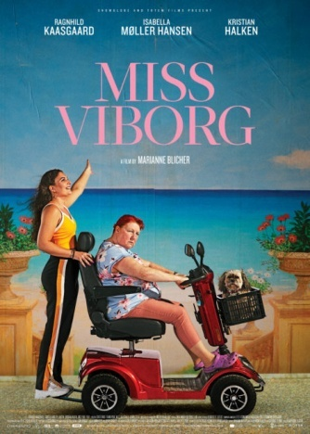
2 | Schoolgirls | Pilar Palomero | Spain | Drama | 97 mins | Schoolgirls is the story of Celia, an 11-year-old girl who studies at a nuns' school in 1992. Celia is a good girl; she is a responsible student and a considerate daughter. The arrival of a new classmate will open a little window through which Celia will discover a whole new world.  Together with her new friend and some older girls, Celia will enter a new stage of her life: adolescence, the stage of first-times. Her body needs to experiment, try new things, and stop being a little girl, even if that entails confronting her mother and everything that meant comfort and security. | 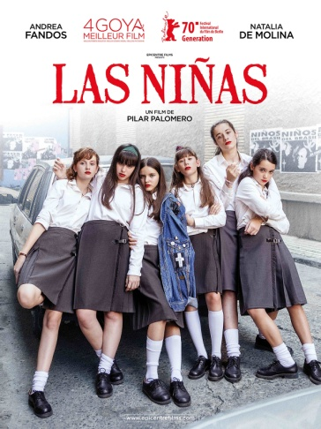
3 | The Naked Truth About Zhiguli | Victor Bojinov | Bulgaria | Comedy | 111 mins | A music producer must assemble his former 30 year-old Rock band and play one last concert to earn enough money for his daughter's expensive education. | 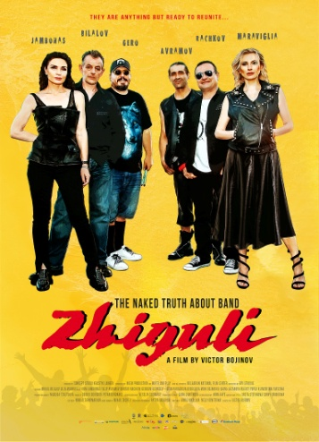
4 | Servants | Ivan Ostrochovský | Czech Republic, Ireland, Romania, Slovakia | Drama | 80 mins | The Catholic Church is having a hard time in Czechoslovakia in the early 1980s. The communist regime threatens to crush it unless it submits to strict control and accepts restrictions on freedom of belief and expression. The clergy is divided into the regime-critical “catacomb church”, which maintains contact with the Vatican and Western media, and the “ecclesiastical hierarchy” which cooperates with those in power and is represented by the state-sponsored priests’ association Pacem in Terris that existed in the ČSSR from 1971 to 1989. This is the context in which young seminarians Michal and Juraj have to decide whether to remain faithful to their vocation and idealism or to bow to pressure from the secret police. | 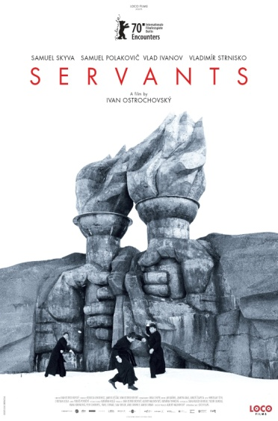
5 | The Banshees of Inisherin | Martin McDonagh | United States, United Kingdom | Black Tragicomedy | 114 mins | Two lifelong friends find themselves at an impasse when one abruptly ends their relationship, with alarming consequences for both of them. | 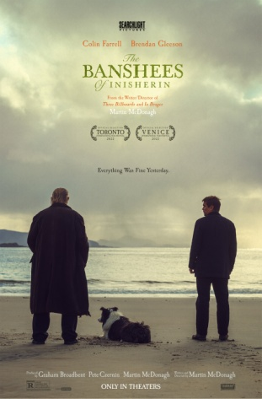
6 | Mikado | Emanuel Parvu | Romania, Czech Republic | Drama | 96 mins | One day, teenager Magda offers her expensive necklace to a sick child in the hospital she volunteers for. Her father is certain she is lying again, and when Magda proves her innocence, he is ashamed and guilty but also incapable of admitting he was wrong. Their relationship is broken and in chaos, and past decisions have irreversible consequences. | 
7 | Tove | Zaida Bergroth | Finland | Drama | 103 mins | The film shows the early life of Tove Jansson from the end of World War II to the mid-1950s, showing her romantic relationships with the politician Atos Wirtanen and the theatre director Vivica Bandler as well as the creation and publication of the Moomins. | 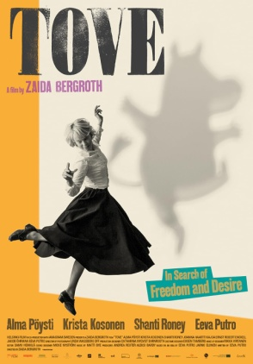
8 | Luxembourg, Luxembourg | Antonio Lukich | Ukraine | Drama | 106 mins | There are many beautiful places to die. Luxembourg is not one of them. But beautiful or not, Luxembourg makes dying very expensive. When twin brothers hear that their long-absent father is sick in Luxembourg, they set out on a journey to see him one last time. Will the man they find be the bad-ass father they remember ? | 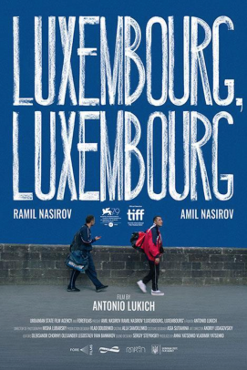
9 | “The Beast” | Rodrigo Sorogoyen | Spain | Thriller | 137 minutes | A French couple move to a Galician town in search of a closer relationship with nature. However, a conflict with their neighbours, the Anta brothers, causes tensions to grow until the situation reaches a point of no return. | 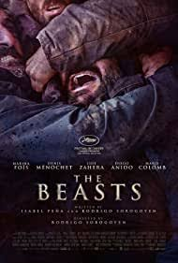

SHORT NEPALI FILMS TO BE SCREENED AT 2024 NEPAL-EUROPEAN UNION FILM FESTIVAL
SN | FILM | DIRECTOR/ORGANIZATION | RUNNING TIME | SYNOPSIS
1 | Voices from the Roof of the World/Dhye Dreams | Shanta Nepali | 27:35 mins | "Dhye Dreams" is a 30-minute documentary that intimately explores the lives of three women fighting against their fate: Sonam Sangmo, Kunchok Dolkar, and Lhakpa Choezon. Most villagers have moved down to a river-fed valley and the new frontier town of Chambaleh, where they hope to grow a commercial apple crop. But Kunchok and Lhakpa stay with their beloved livestock and fields up in the mountains. Their stories highlight the resilience and struggle for the survival of isolated Himalayan villages battling against dramatic climate change.
2 | Divination (Aakhat) | Gopal Acharya | 14: 46 mins | A shaman loses his power to heal people.
3 | Hawaman | Samal Bajracharya | 11:13 mins | A boy who is avid fan of batman tries to emulate him.
4 | Kathmandu Monsoon | NgimaGelu | 18.18 mins | A cinematic portrayal of Kathmandu during monsoon.
5 | Makhmali Udan (Breaking the Boundary) | Atin Shrestha | 24:50 mins | 'Makhamali Udaan' is a story of a brother and a sister from a low-income class, who go on to cross their personal boundaries to set off into the flight of their own interests while also becoming each other's strongest support.
6 | #LetsTalk PERIOD - Breaking Taboos in Nepal | Director Rajin Maharjan  Organization GIZ | 5:39 minutes | The short film “#LetsTalkPERIOD - Breaking Taboos in Nepal” tries to break the taboo around menstruation in Nepal with a special focus on the supporting role of men/fathers and "positive masculinity" in general.
7 | Rato Paccheuri (A tale of turmoil, temptation & triumph) | Miraz Roshan Thakuri | 26 minutes | A resilient female sex worker battles against the abusive clients, a violent husband, and corrupt law enforcement. As she grapples with the harrowing realities of her profession, her fight intensifies against a society that denies her basic rights, refusing citizenship  and a birth certificate for her child. Through perseverance and solidarity, she strives to break free from the chains of oppression, seeking justice and a brighter future.
8 | Sanai | Akanchha Karki | 14:24 mins | Two young girls play out their friendship to make fun of untouchability in Nepali society.
9 | The bull, the Cow, the Calf | Swoyan Maskey Manandhar | 13:37 mins | In the midst of social divides, 'The Bull, The Cow, and The Calf' reveals the toll of family conflict on children. As financial tensions rise between parents, their son quietly observes their arguments. Trapped between their struggles and a desire for peace, the boy confronts the loss of innocence in their turbulent home.
10 | The Mirage | Santosh Dahal | 26:30 mins | Set in Nepali village ‘’ The Mirage’’ is a poetic, meditative journey of Manish who embarks to his uncle’s house with his mother at the time of civil war. Through this journey, he discovers a beggar who changes his religion for liberation, a rebellion fighting for emancipation from capitalism, and his uncle who wants freedom from rebellion group. In this ecological narrative he discovers three different life heading in a different way to achieve the common value of liberation that seems like mirage.
11 | Whirl | Anil Kurmi | 9:04 mins | Forsaking his job abroad, a young man returns to Nepal dreaming to start agriculture in his own village only to find himself impeded by dirty politics.

