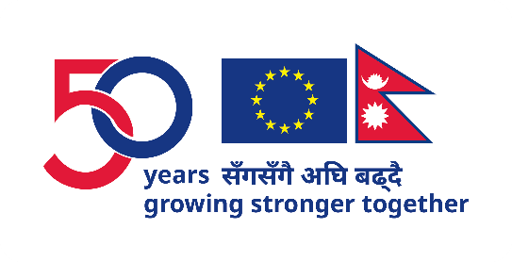

Nepal European Union Film Festival (NEUFF) 2024
Detailed Schedule
Koshi Province
Itahari ( 15 to 18 Nov, 2024)

14th Nov
Time | Films / Programmes
15:00 hrs | Press Meet, at the hotel of residence of the EU Officials

15th Nov
Time | Films / Programmes
16:30 – 17:00 | Reception (Through invitation only)
17:00 – 17:15 | Opening Remarks (Virtual)  by EU Ambassador to Nepal H.E. Veronique LORENZO
17:30 | Films Exhibition
 | Nepali Short | Sanai  (Dir: Akanchha Karki)  (15 min.)
 | EU Film | The Naked Truth about Zhiguli Band  (2022 | BULGARIA)  (111 min.)  (Language: Bulgarian | Subtitles: English, Nepali)

16th Nov
Show Start Time | Films
11:00 | Side Event | Topic: Challenges & Opportunities of the Nepali  film industry  Expert 01: Mr. Manoj Pandit (Writer/Director)  Expert 02 (Local): TBD  Expert 03 (Local): TBD  Moderator: TBD  (120 min.)
13:30 | Nepali Shorts | Whirl  (Anil Kurmie)  (10 min.)
13:30 | EU Film | Lola  (2022 | IRELAND, UNITED KINGDOM)  (79 min.)  (Language: English | Subtitles: English)
15:45 | Nepali Shorts | Let’s Talk Period  (Dir: Rajin Maharjan)  (6 min.)
15:45 | EU Film | La Pirogue  (2011 | SENEGAL FRANCE, GERMANY, HAITI)  (87 min.)  (Language: Wolof | Subtitles: English, Nepali)
18:00 | Nepali Short | Rato Pachhauri  (Dir: Miraz Roshan Thakuri)  (26 min.)
18:00 | EU Film | Lamb  (2015 | ETHIOPIA, FRANCE GERMANY, NORWAY)  (89 min.)  (Language: Amharic | Subtitles: English, Nepali)

17th Nov
Show Start Time | Films
11:00 | Nepali Short | Makhamali Udaan  (Dir: Atin Shrestha)  (25 min.)
11:00 | EU Film | The strange case of Jacky Caillou  (2022 | FRANCE)  (92 min.)  (Language: French | Subtitles: English, Nepali)
13:45 | Nepali Short | Kathmandu Monsoon  (Dir: Ngima Gelu Sherpa)  (19 min.)
13:45 | EU Film | Schoolgirls  (2020 | SPAIN)  (97 min.)  (Language: Spanish | Subtitles: English Nepali)
16:30 | Nepali Shorts | Divination  (Dir: Acharya Gopal)  (15 min.)  Dhye Dreams  (Dir: Shanta Nepali)  (28 min.)
16:30 | EU Film | Miss Viborg  (2022 | DE NMARK)  (99 min.)  (Language: Danish, German | Subtitles: English Nepali)

18th Nov
Show Start Time | Films
11:00 | Nepali Short | Hawaman  (Dir: Samal Bajracharya)  (12 min.)
11:00 | EU Film | Le Petit Nicolas  (2022 | FRANCE, LUXEMBOURG, CANADA)  (103 min.)  (Language: French | Subtitles: English)
13:45 | Nepali Shorts | The Bull, The Cow & The Calf  (Dir: Swoyam Maskey Manandhar)  (14 min.)  The Mirage  (Dir: Santosh Dahal)  (27 min.)
13:45 | EU Film | Luxembourg Luxembourg  (2022 | UKRAINE)  (106 min.)  (Language: Ukranian, German | Subtitles: English Nepali)
17:00 | Nepali Short | Sanai  (Dir: Akanchha Karki)  (15 min.)
17:00 | EU Film | The Naked Truth about Zhiguli Band  (2022 | BULGARIA)  (111 min.)  (Language: Bulgarian | Subtitles: English Nepali)

