Communications pack

Call for Applications: GCRP 2024

Are you curious about bringing an interdisciplinary and cross-sectoral practice to your work? Are you keen on interacting meaningfully with professionals from another sector and addressing global challenges?

The Global Cultural Relations Programme (GCRP), the Cultural Relations Platform’s flagship training programme, is a unique opportunity that brings together practitioners from around the world to create meaningful connections and discuss cross-cultural collaborations. The 2024 edition of GCRP is open to cultural and creative professionals OR participants working in the field of creating safer societies.

Apply now for the opportunity to develop lifelong skills, increase your knowledge, build your international network, and engage in interdisciplinary cross-cultural collaboration.

This year the GCRP will take place in Marrakech, Morocco from 25 – 28 November 2024.

The programme will be conducted in English.

Who can take part in the GCRP?

- Cultural and creative sector professionals
This includes but is not limited to:
- Architecture
- Audiovisual & Cinema
- Books & Publishing
- Cultural heritage
- Cultural management
- Design
- Media
- Music
- Performing arts
- Visual arts

- Professionals working in the field of creating safer societies:
This includes but is not limited to:
- Conflict and post-conflict areas
- Peacebuilding
- Mediation practices, dialogue, and education
- Post-conflict trauma healing and mental health
- Interfaith dialogue
- Human rights and rights-based initiatives
- Working with marginalised groups
- Social justice, inclusion, and resilience
- Asylum, migration, and forced displacement
- Natural disaster and climate change responses
- Actions against disinformation

Why take part in the GCRP?

- Build your skills in interdisciplinary and cross-cultural collaborations through a carefully designed, innovative, and interactive learning programme
- Collaborate with professionals from around the world who are facing similar challenges and opportunities
- Connect with young practitioners and change-makers working in the field of culture or creating safer societies to engage in peer-to-peer learning
- Engage in in-depth discussions on the intersectionality of culture and creating safer societies to identify strengths in bringing together the two sectors for potential future collaborations
- Join the Cultural Relations Platform’s community of 260 GCRP alumni on a long-term basis.

Who are we looking for?

- The Cultural Relations Platform is looking for 40 professionals and entrepreneurs working in the cultural and creative sectors OR in creating safer societies. We give high priority to participants working in either of these two sectors. Applications from those not working in the cultural and creative sectors or in creating safer societies will not be considered.
- You should be aged 25-39, with at least three years’ experience in global/international/cross-cultural collaboration.
- You could work for a public, private, or civil society organisation, or be a freelancer.
- You will need to be able to commit to the programme throughout its duration from 25 – 28 November 2024 and allow time for travel to and from Marrakech.

Timeline:
- Mid- to late August: Selected participants are informed via email
- October: Selected participants are announced online
- Sunday 24 November: Participants arrive in Marrakech
- Monday 25 November – Thursday 28 November: Four full days of programming
- Friday 29 November: Participants departure from Marrakech

How to apply

Find out more and apply here by midnight Central European Summer Time (CEST), 14 July 2024 (Sunday): https://www.cultureinexternalrelations.eu/2024/06/14/apply-for-the-global-cultural-relations-programme-2024/

The read-only application form is also available to download in PDF https://www.cultureinexternalrelations.eu/wp-content/uploads/2024/06/GCRP-2024-Application-Form_Fillable-PDF.pdf. Applications will only be accepted via the link above.

The application form must be completed in English. Applications submitted in another language will not be considered.
If you use AI software to generate content for your application, please make sure to use them in limited ways and remember to personalise your text. Please take note that unedited “copy-and-paste” AI generated response applications will not be considered.
Please note that if you are a full-time employee of any of our consortium partner organisations (Goethe-Institute e.V., IETM, European Cultural Foundation, University of Siena) or if you are a full-time employee of an EU institution, service, or agency, you are not eligible to participate in GCRP.
For further questions, please send an email to: cultural.relations.platform@goethe.de.
The Cultural Relations Platform remains committed to providing accessible services and support to people with disabilities and reduced mobility (including accessible venue and accommodation selection, travel-related requirements) as well as for access requirements for programme participation (such as hearing or visual support and adaptations for neurodiversity).

Social media

#GCRP2024
Twitter: @cultextrel
Facebook: @cultureinexternalrelations
Instagram: @culturalrelationsplatform
LinkedIn: @Cultural Relations Platform

Facebook | Opportunity alert 📢  The Global Cultural Relations Programme (#GCRP) from @cultureinexternalrelations is now open for applications!  If you work in the cultural and creative sectors or the field of creating safer societies, apply for #GCRP2024 for the chance to widen your skills in international cultural relations and your network of peers worldwide 🌎  📍The programme will take place in Marrakech, Morocco and be conducted in English.  Apply by 14 July 👉 tinyurl.com/GCRP2024
Instagram | Opportunity alert 📢  The Global Cultural Relations Programme (#GCRP) from @culturalrelationsplatform is now open for applications!  If you work in the cultural and creative sectors or the field of creating safer societies, apply for #GCRP2024 for the chance to widen your skills in international cultural relations and your network of peers worldwide 🌎  📍The programme will take place in Marrakech, Morocco and be conducted in English.  Apply by 14 July 👉 tinyurl.com/GCRP2024
LinkedIn | Opportunity alert 📢  The Global Cultural Relations Programme from @Cultural Relations Platform is now open for applications!  If you work in the cultural and creative sectors or the field of creating safer societies, apply for #GCRP2024 for the chance to widen your skills in international cultural relations and your network of peers worldwide 🌎  📍The programme will take place in Marrakech, Morocco and will be conducted in English.  Apply by 14 July 👉 tinyurl.com/GCRP2024
Twitter  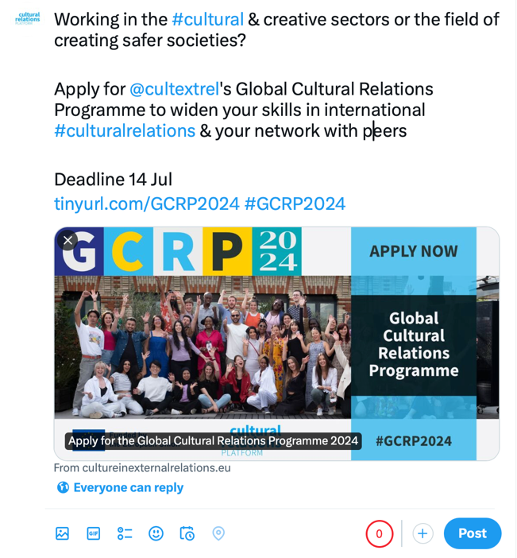 | Working in the #cultural & creative sectors or the field of creating safer societies?  Apply for @cultextrel's Global Cultural Relations Programme to widen your skills in international #culturalrelations & your network with peers  Deadline 14 Jul  tinyurl.com/GCRP2024 #GCRP2024

