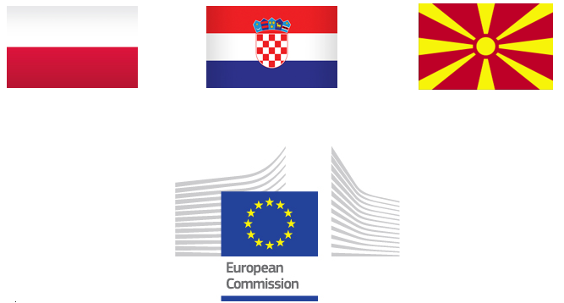

Job Announcement
for Language Assistant to the Resident Twinning Adviser (RTA)
European Union Twinning Project (Ref. MK 22 IPA TR 01 24)
“Supporting the inspection services for transportation of passengers and goods”

A Language Assistant to the Resident Twinning Adviser (RTA) is sought for an EU Twinning Project entitled “Supporting the inspection services for transportation of passengers and goods”- MK 22 IPA TR 01 24 implemented, in the Republic of North Macedonia.
The Twinning Project “Supporting the inspection services for transportation of passengers and goods” is a joint project between the Republic of North Macedonia represented by Ministry of Transport and Communications – State Transport Inspectorate, North Macedonia and General Inspectorate of Road Transport in Warsaw, Poland and Croatian Ministry of the Sea, Transport and Infrastructure.
The overall objective of the project is to to enhance compliance and safety of road transport in Republic of North Macedonia and strengthening of operational capacities and administrative efficiency of the State Transport Inspectorate (STI), ensuring proper enforcement of the national and EU standards for roadside and in-premise inspections of goods and passengers carriers.

Position: full-time Language Assistant
Duration: up to 24 months
Starting Date for Employment (Indicative): October 2024
Place of Employment: Skopje, Republic of North Macedonia

- Requirements:
- Successfully accomplished higher education;
- Mother tongue: Macedonian;
- Excellent spoken and written command of English;
- Ability to accurately interpret and translate from/to English/Macedonian languages, with professional experience within an international office, preferably in the public administration sector.
- Excellent drafting skills in English;
- Advanced computer skills, including a first-class command of Microsoft Word, Excel, PowerPoint and Outlook;
- Ability to work under pressure and to meet set deadlines with a willingness for hard work and to be flexible;
- Knowledge of Albanian (spoken and written) and ability to interpret and translate from/to English/ Albanian will be an asset;
- Training or professional experience in international environment;
- Previous experience in translating/ interpretation.

- Tasks
- Supporting the RTA and other project experts in their day-to-day activities as Project translator and interpreter;
- Providing translation and interpretation in the preparation and implementation of activities, such as training, meetings, workshops, seminars or other circumstances as required;
- Providing translation and interpretation assistance in the preparation of studies, documents and other material, in the areas covered by the Twinning;
- Assisting the RTA in drafting the minutes in Macedonian and English of the Steering Committee Meetings and other meetings /events related to the Project;
- Reviewing, translating and editing text relevant to the project (newsletters, press releases, PowerPoint presentations and documents) in English and Macedonian;
- Accompanying the RTA or other project experts to meetings, workshops, seminars as well as to missions and field visits throughout North Macedonia and EU (for activities outside Skopje only travel and accommodation costs will be reimbursed);
- Providing general support for RTA and/or other experts with Beneficiary Country (BC) partners and/or authorities, with particular reference to the assistance and management of mission reports and other documents provided by them;
- Assisting the RTA in communications, liaison and general working relations with BC public offices and institutions, relevant to project activities;
- Providing assistance, including linguistic one, to the BC and Member State (MS) Administration associated with the Twinning, as and when required;
- Maintaining a high level of ethical behavior and acting in a non-discriminatory manner at all times;
- Respecting, actively supporting and, where appropriate, contributing to the overall aims and objectives of the Project;
- Following the Project policy regarding behavior, appearance, health, safety, security, payment regimes, and use of Project equipment etc;
- Performing temporarily RTA assistant in case of his/her unavailability at work;
- Maintaining confidentiality in all matters relating to the work of the Project.

- Selection procedures and deadline for the submission of the application
How to apply
CV (Europass format), cover/motivation letter in English language and copy of the Passport will be sent to the following e-mail addresses: Michal.Rzemieniewski@gitd.gov.pl and international@gitd.gov.pl.
The following documents should be annexed in scanned versions to the application:
- Certificate on educational qualification;
- Certificate of language knowledge;
- References from previous employer(s) if available.
Deadline: 2 September 2024 Time: 18:00 Central European Time
Should the CV’s arrive beyond the above-mentioned deadline, they will be not taken into consideration.
Only shortlisted candidates will be informed and invited to an interview (beginning of October 2024).
- Additional job information
- Applicants shall not have been involved neither in the selection process nor in the drafting of the Contract.
- The RTA assistants may not have or recently (past 6 months) have had any contractual relation with the beneficiary administration that is the Public Administration of the Beneficiary Country.
- The assistant will sign a full-time service contract and must have a status of self-employed. It will be his/her sole responsibility to comply with all legal requirements for self-employment as well as to cover all related taxes and charges.
- By submitting the application, the candidate declares to know the content of the Art. 13-14 of the EU Regulation UE 2016/679 (GENERAL DATA PROTECTION REGULATION - GDPR) regulating the treatment of the personal data

