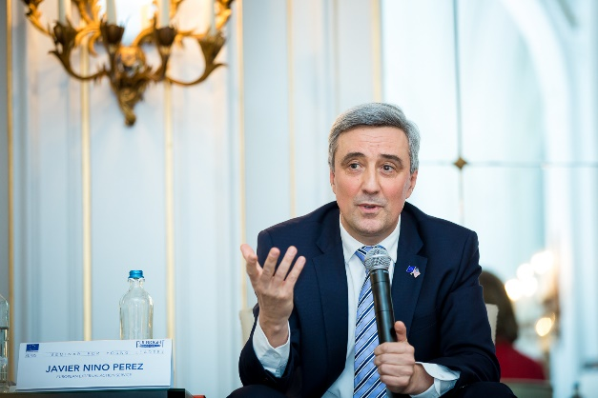 | Javier NIÑO PÉREZ
Nationality: | Spanish
Academic qualifications: | - 1993  - Masters of Arts – Advanced Political studies  - College of Europe, Bruges,  - 1991  - LLM European Law  - Free University of Brussels, Belgium  - 1990  - Degree in Law  - University of Valladolid, Spain
Professional experience: | - 12.2019 -  - Director/Deputy Managing Director Americas, EEAS  - (07.2020 | 11.2020  - Acting Managing Director Americas, EEAS)  - 09.2018 | 06.2020  - Head of Division US and Canada, EEAS  - 09.2015 | 08.2018  - Head of Division Turkey, EEAS  - 09.2012 | 08.2015  - Ambassador-Head of Delegation,  EU Delegation Haiti  - 09.2007 | 08.2012  - Chargé d’Affaires-Head of Delegation,  EU Delegation Cuba  - 09.2005 | 08.2007  - Principal Administrator Latin America and Caribbean, Horizontal matters Unit, DG Relex, European Commission  - 09.2002 | 08.2005  - Principal Administrator Conflict Prevention/Crisis Management and ACP Political Issues Unit, DG Relex, European Commission  - 09.2001 | 08.2002  - Head of Political and Economic Section, EC Delegation Trinidad & Tobago  - 12.1997 | 08.2001  - Head of Political and Economic Section, EC Delegation Burkina Faso  - 04.1994 | 12.1997  - Administrator, DG Trade, European Commission
Language Skills: | - Spanish (Mother tongue)  - English  - French

