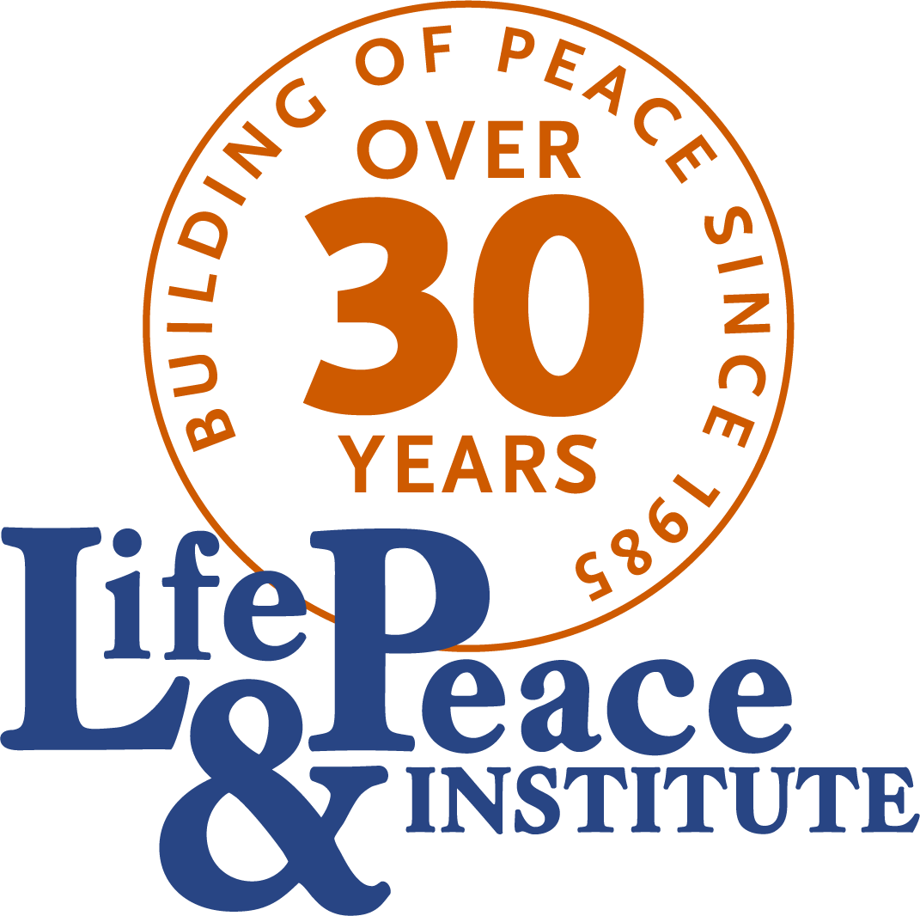
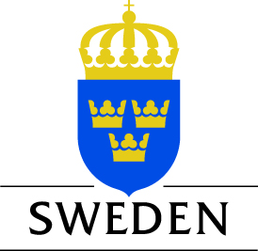


April 6, 2017
Press release
For Immediate Release

The Life & Peace Institute’s Horn of Africa Regional Programme will lead a 3-year project financed by the European Union. The project, launched on 28 March 2017 in Addis Ababa, will contribute to policies that prevent border-related conflicts in the Horn of Africa. People living in border areas will participate in decision-making on border issues through the project which will build the capacities of civil society organisations (CSOs) to engage and support more effective and sustainable policies.

This project is timely particularly since, “border conflicts don’t often receive the attention they deserve,” said Ambassador Frederic Gateretse-Ngoga, Head of the African Union Conflict Prevention and Early Warning division.

One of the expected outcomes will be improved cross-border cooperation between CSOs along parts of the Ethiopia-Kenya, Kenya-Uganda, and Sudan-Eritrea borders. The partners involved in the implementation of the project alongside the Life & Peace Institute (LPI) are crucial actors in the Horn of Africa Region: Inter-Africa Group (IAG, Ethiopia), Act Change Transform (ACT!, Kenya) and Eastern Africa Sub-regional Support Initiative for the Advancement of Women (EASSI) of Uganda.

“This project is exciting for us because it provides us with a wider scope in terms of conflict prevention and gives us the opportunity to reach marginalised regions of Kenya,” said Ms. Anne Nyabera, Executive Director of ACT!

Emphasising how valuable the project is, the Executive Director of LPI Dr. Judy McCallum said, “Borders offer both opportunities, as well as some significant challenges to those who live in border regions. Policy makers do not always know the diversity and breadth of these issues, and therefore they are not taken into account as national and regional policy is developed. Through this programme, Life & Peace Institute and its partners will bring the reality of these issues and the lived experience of people to the attention of those who make the policies.”

Tuesday’s event brought together European Union representatives, the African Union and the Inter-Governmental Authority on Development (IGAD) under the
theme, “Improving policies for conflict prevention: Civil society engagement to transform borderlands in Africa.”

more follows

The project was officially launched by Mr. Ruben Alba Aguilera, representing the European Union Delegation to the African Union who said:

“Together we need to overcome the negative views around borders. This project funded by the European Union is an excellent opportunity to change those perceptions while making a substantial contribution to conflict prevention and the development of borderlands.”

The cost of the 3-year project is EUR 2 983 172 (approx. ETB 71.5 million) and is funded by the European Union with co-financing provided by the Government of Sweden.

End

For more information on the project please contact:

Hannah Tsadik
Resident Representative
Life & Peace Institute in Addis Ababa, Ethiopia
Wollo Sefer, Ethio-China Friendship Avenue
Addis Ababa, Ethiopia
Tel: + 251 (0) 115 51 36 70
hannah.tsadik@life-peace.org

