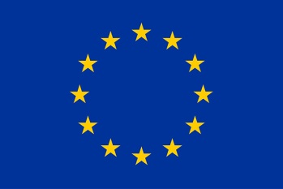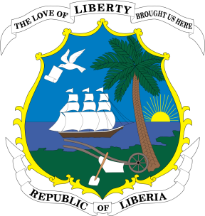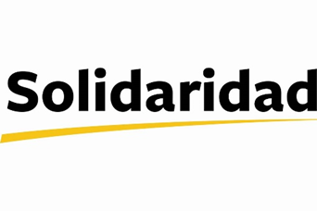

Liberia Cocoa Sector Improvement Programme (LICSIP)

Today, the Delegation of the European Union to Liberia and Solidaridad West Africa in the presence of the Ministry of Agriculture, have signed a 5 million euros grant agreement to develop the cocoa sector in Liberia.
Cocoa has the potential to improve many smallholder cocoa farmers’ livelihoods in Liberia. However, the Liberian cocoa sector is still largely uncompetitive compared to neighbouring countries. Average yields in Liberia lag behind due to a number of reasons, including low quality planting materials, aged and un-rehabilitated farms, poor farm management, and lack of post-harvest management skills.
In recognition of the potential of the sector, the Government of Liberia prioritised the development of the cocoa sector under the Liberia Agriculture Transformation Agenda (LATA). In support of that strategy the EU launched a call for expression of interest in April of this year to encourage local and international organisations in Liberia to develop ideas for the commercial development of the cocoa sector. This call led to the selection of the Liberia Cocoa Improvement Programme (LICSIP) with Solidaridad West Africa as implementing Partner.
The Liberia Cocoa Sector Improvement Programme aims to create a vibrant, competitive and profitable cocoa economy driven primarily by farmers’ organizations and supply chain companies within a robust national regulatory and institutional framework.
In concrete terms, the project envisages training 5000 cocoa farmers in good agriculture practices and improved farm management over the life of the project. Employment opportunities will also be created for women and youth through cocoa value chain service provision businesses.
The project will also support the government of Liberia with the creation of sector policies and the development of coordinating structures.
Finally, Solidaridad intends to increase profits for Liberian businesses by exporting high quality cocoa beans, and by linking Liberian businesses to international cocoa traders
The project core counties are Bong, Nimba and Lofa, with Grand Gedeh, with River Gee and Gbarpolu as the secondary counties. The project will be executed over a period of 4 years with an option to expand to other cocoa growing communities if the programmes proves successful.
In all, the European Union has allocated a total of 8.5 million euro for the development of the cocoa sector in Liberia. This grant of 4 million euro is the first phase of that allocation.
Development of the cocoa sector is one of the four priority areas identified by the European Union and the Government of Liberia under the EU-Liberia Agriculture Programme. The other priority areas are rural development (12 million euro), capacity building for the ministry of agriculture (2 million euro) and fisheries (7 million), totalling 30 million euro.
The signing of this contract today marks the start of the implementation of the EU Liberia Agriculture Programme (EULAP), with further contracts expected to be signed in the next six months.
A partnership agreement to officially start the project as of 15 January 2018 was signed today by Emma Sundblad, Chargé d’affaires of the delegation of the European Union, Isaac Gyamfi, Regional Director for Solidaridad West Africa, and Aaron Marshall, Deputy Minister at the Ministry of Agriculture.
About EU in Liberia
The European Union is made up of 28 Member States who have decided to gradually link together their know-how, resources and destinies. Together, during a period of enlargement of 50 years, they have built a zone of stability, democracy and sustainable development whilst maintaining cultural diversity, tolerance and individual freedoms. The European Union is committed to sharing its achievements and its values with countries and peoples beyond its borders. In Liberia, we have allocated €279m to support good governance, energy, education and agriculture in the period between 2014-2020. In addition, Liberia benefits from regional funds earmarked for West Africa and from a number of thematic programmes.
For more information: https://eeas.europa.eu/delegations/liberia or www.facebook.com/EUinLiberia/

About Solidaridad
Solidaridad has built a reputation as a catalyzer for sustainable innovations in commodity supply chains over the past 50 years. Our work has the goal of improving livelihoods for vulnerable producers, while respecting the planet, each other and the next generation. As an international development organization, we operate on five continents through nine Regional Expertise Centre’s (RECs). We focus on producing more with less and ensuring it is done in a way that is good for people and the environment. Solidaridad West Africa operates in Cote d'Ivoire, Ghana, Liberia, Nigeria and Sierra Leone. We are currently managing various programmes and projects in cocoa, oil palm, maize and gold commodities.
For more information: www.solidaridadnetwork.org/regions/west-africa

