|  |  |
| --- | --- |
| **Implementing organisation(s)** | *Government of Kyrgyzstan* |
| **Duration** | *Phase II:*  *2019 –2021[1]* |
| **Project budget** | *Total budget € 35.823 million*  *EU contribution € 35.76 million[2]* |
| **Project partners** | *Ministry of Education and Science, Ministry of Finance, Vocational Education Agency.* |
| **Location** | *Kyrgyzstan (nationwide)* |
| **Keywords** | *Education reform, quality education, inclusive education, budget support, Kyrgyzstan* |

**Program Objective**

The objective of the Programme is to contribute to an inclusive and equitable quality of education, promote lifelong learning opportunities for all and gender equality during the education process. The Programme is done through budget support, thereby creating fiscal space for support the governmental sector implementation of reform.

**Main target groups** - Government, educational institutions and NGOs

**Key challenges that the program helps to address**

* While important progress has been made in terms of educational access, challenges persist in the areas of learning outcomes. Despite high level of education spending, learning outcomes remain low.
* The financial resources to develop the Sector are available, but are presently used inefficiently and ineffectively.
* Marginalised groups such as disabled children, children in remote villages, and the very poor experience difficulties to access the education system.

***Expected outcomes***

* Greater clarity and effectiveness in the general and financial management of the education sector;
* Increased access and quality to educational provision leading to improved learning outcomes;
* A strengthened institutional framework for management, transparency and monitoring of the institution's performance;
* An education system that is more cost-effective, better managed, more tailored to the needs of the labour market and attractive to students and employers.

**Budget Support mechanism:**

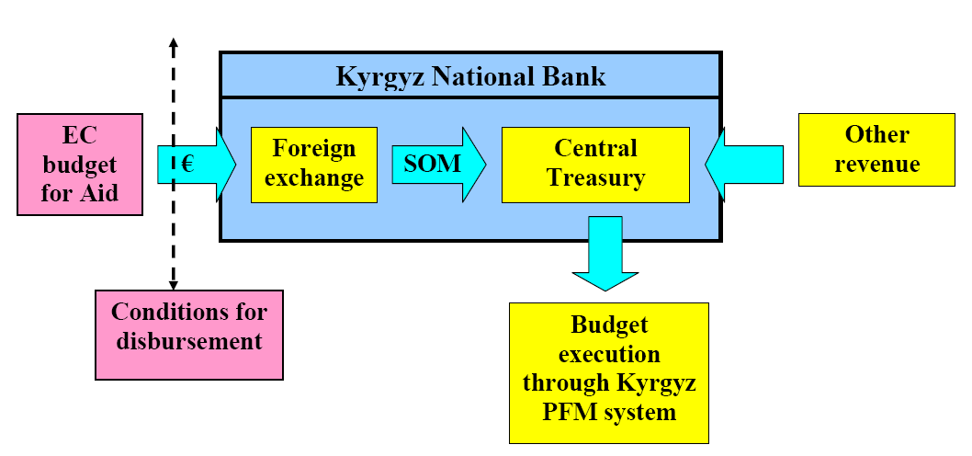

**Implementation status:** Ongoing

1. The program is financed from the Multiannual Indicative Programme 2014-2020: phase 1 covered the period 2016-2018.
2. Total program budget is € 71,76 million.