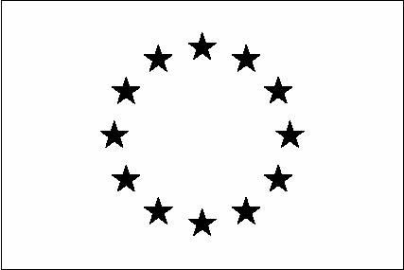
2022 EU Human Rights Defenders Award

Nomination Form

Nominating Organisation/ Individual:
Name:
Phone Number:
Email address:

Human Rights Defender Award Nominee:
Name:
Organisation:
Why does the nominee deserve this award?
(Description of contributions to human rights, achievements and other relevant qualities over the past year - maximum 120 words)

Please email this nomination form to edith.okech@eeas.europa.eu before 17:00 (EAT) on Friday 4th March 2022.

By completing and submitting this nomination form, you are consenting for your name and contact details to be held on file by the European Union Delegation to Uganda, by the European Union Member States represented in Uganda and by the Embassy of Norway for the duration of this award procedure. Your data will be held on a secure server and we will not keep your details for longer than necessary.

