Implementing organisation(s) | Government of Kyrgyzstan
Duration | 2015-2020
Project budget | Total budget - € 30 million  EU contribution - € 30 million
Project partners | Ministry of Labour and Social Development, Ministry of Education and Science, Ministry of Finance.
Location | Kyrgyzstan (nationwide)
Keywords | Poverty alleviation, social protection, Kyrgyzstan.

Program Development Objective
The project aims to sustain poverty alleviation and promote social justice through supporting the development of an efficient social protection system in line with the country's sector policies and strategies.

Main target groups
Government, local authorities, families with children, opinion makers, mass media, non-governmental organisations and civil society organizations.

Key challenges that the program helps to address:
- Poor quality of social services, especially for the children in difficult life situation;
- High rates of poverty and extreme poverty
- High rates of labour migration and unemployment
- Vulnerability to external shocks

Expected outcomes
- Improved access to and availability of quality community social services for the most vulnerable parts of the population, in particular children;
- Strengthened management capacity of the Government at central, regional and local level to implement social and child protection reforms;
- Strengthened policy based budgeting
- Improved coverage and quality of internal audit functions;
- Enhanced internal audit capabilities within institutions associated with the programme to strengthen effectiveness and accountability;
- Increased pro-poor targeting of social assistance.

Budget Support mechanism:
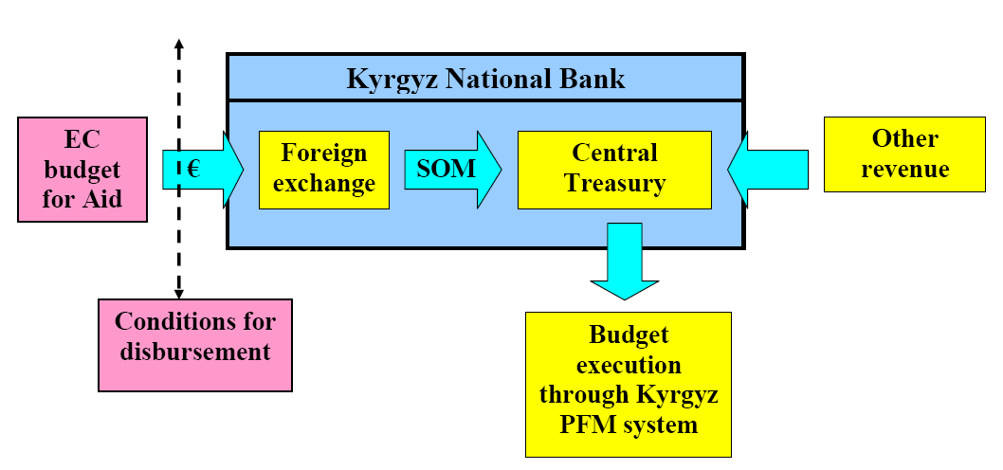

Implementation status: Ongoing

European Union allocated EUR 26 million in budget support and EUR 4 million in complementary Technical Assistance.

