Centre for Coordination of Youth Activities

CCYA
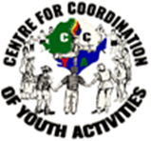

REPORT
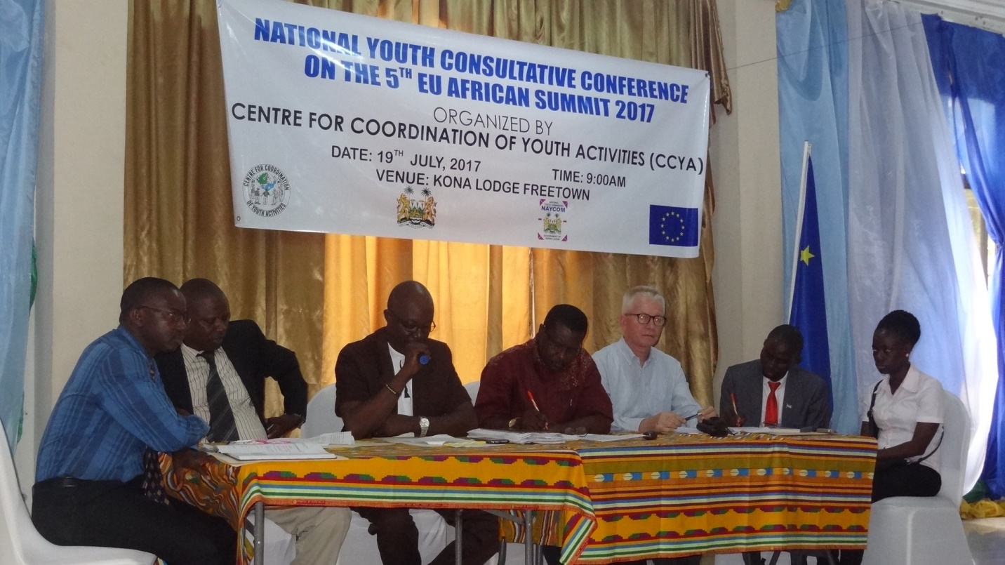
National Youth Consultative Conference
Freetown
July 2017

- Introduction
Sub-Saharan Africa (“the region”) is the youngest region in the world, and its youth population is growing rapidly. That is why Africa’s youth are easily considered as a destabilizing force that threatens the region’s security—a concept sometimes referred to as the “youth bulge and instability theory”—often focusing on concerns about unemployment, unrest, and violence. An alternative to this narrative is that the potential of Sub-Saharan Africa’s youth can be unlocked to create peace and prosperity for the region, a narrative found in national frameworks, such as the various National youth policies, regional frameworks— such as African Youth Charter—and global frameworks—such as United Nations Security Council Resolution 2250. Youth have the potential to be a great asset for Sub-Saharan Africa’s development, but only if the state engages with and invests in youth.
Centre for the Coordination of Youth Activities (CCYA) in collaboration with the Ministry of Youth Affairs (MOYA) and National Youth Commission (NAYCOM) has organized a one day national youth consultative conference on the 5th EU-Africa Summit that is scheduled to take place in Ivory Coast on the 28-29 November this year with the theme “YOUTH”. The conference was held on Wednesday 19th July 2017, at Kona Lodge, Freetown. The consultation brought together over 75 young people aged 18 – 35years from District Youth Councils, National Youth Council, youth groups, civil societies, MDAs and the media from the fourteen districts of Sierra Leone. The one day national youth consultative conference was funded by the European Union Commission in Sierra Leone.
1.1. Objective
The conference typically is to consult Youth Leader between (18-35 years) on issues of concern to the Youth development in Africa.

1.2. Outcomes
The following were core outcomes that generated from the one-day national youth consultation;
- A presentation on Youth Empowerment and Employment in Sierra Leone: “Status, Challenges and Prospects”
- Group Plenaries on four broad topics: “General Status of Youths in Sierra Leone, Existing Opportunities for young people, Challenges/Barriers faced by Youths and Identify Concrete Steps that can be taken – Identifying he key players (i.e GoSL,Youth Serving Agencies, Youth Leader/Groups, International Organizations
- Development of a position paper cataloging the concerns and recommendations of young people to be presented in the November EU – Africa Youth Summit in Abidjan, Ivory Coast.
- Establishment of a small working group to compile the issues from the group plenaries to develop the position paper.

  - Opening Ceremony
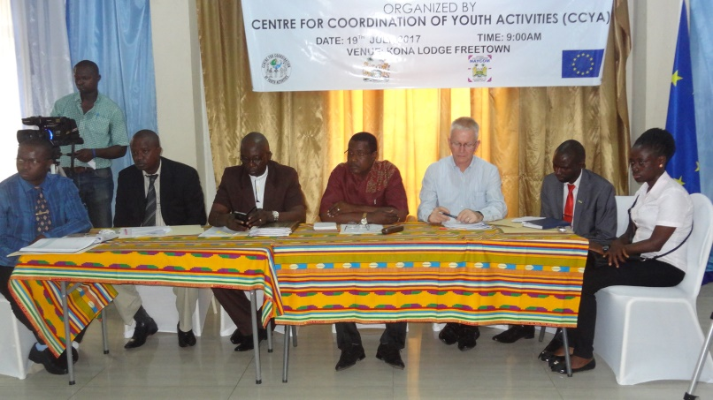
The Chairman Mr. Charles Lahai in his opening statement welcomes all participants to the national youth consultative conference. He said the conference will be looking at the situation of young people within the special package that will promote and protect the welfare of young people. In Africa the youth population continues to grow and there is the need to promote skills and technology among youths. The environment also plays an integral role on the challenges that Sub-Sahara youth faced with regard to participation in decision – making processes. Today the conference hopes to bring out strategies that would prevent the region from issues that limit their participation. Ending his statement, he encouraged all to be guided in the deliberations for the concept of society and culture. Society sees young people as movers and shakers of society.
Chairman - Charles Lahai
1.4. Overview of the Consultation
A presentation on the overview was done by the Executive Director, Ngolo Katta. Presenting to participants, the director gave a background on the African Union – European Summit. He explained that Sub-Sahara Africa region is the youngest region in the world, and its youth population is growing rapidly. This is why Africa’s youth are easily considered as destabilizing force that threatens the region’s security.
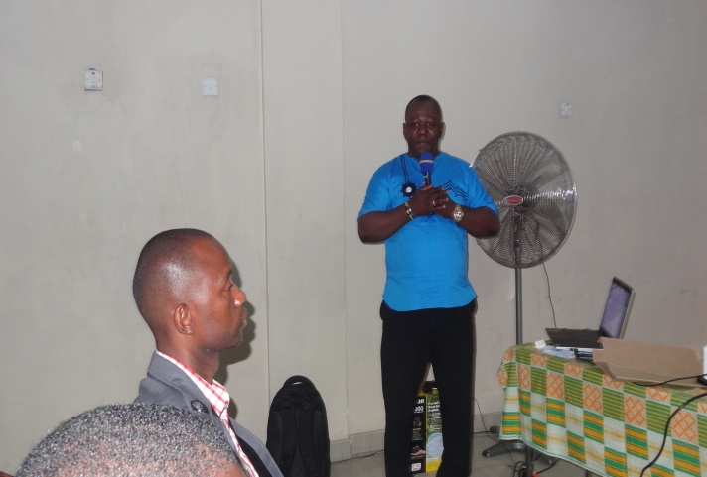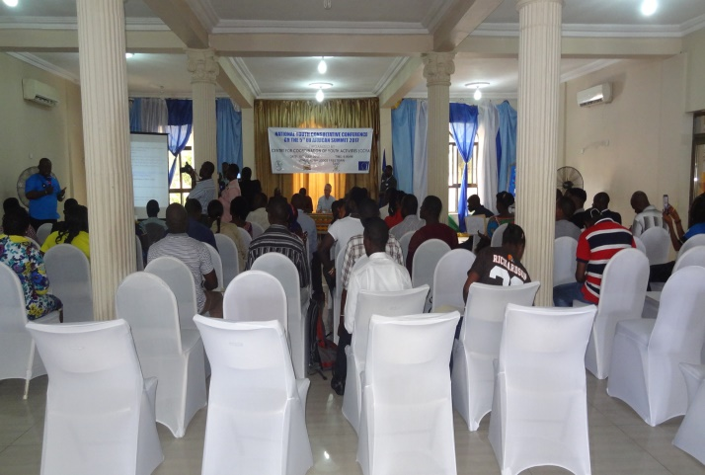
As the region’s youth population grows, skill and familiarity with technology will become an increasingly important factor in the region’s future prosperity. In many countries in the region however, public policy regarding technology is weak or non-existent, and technology particularly social media has transformed the landscape for civic and social engagement by youth. The environment also plays an important role in the challenges that sub-Sahara African youth face with regard to participation in decision making processes, public health and employment.
In the 28th Summit of Heads of State and Government of the African Union held on the 30th January. 2017, Heads of State have expressed their commitment to mainstreaming youth’s programs in all socio-economic activities to uphold the maintenance of peace and stability in the continent.
Sierra Leone Youth Development Programme 2014 – 2018 indicate that 60% of the young people (between 18 and 35 years) are unemployed and over 80% of the country’s young people live below the poverty line of US$2 per day. This marks a major social and economic problem with implications for peace and stability. Ending his presentation, the director urged participants bring out recommendations to be a position paper that will speak the mind of many young people in the country. (See Consultation Concept Note – Annex A)
1.5. Statements
National Youth Commission (NAYCOM)
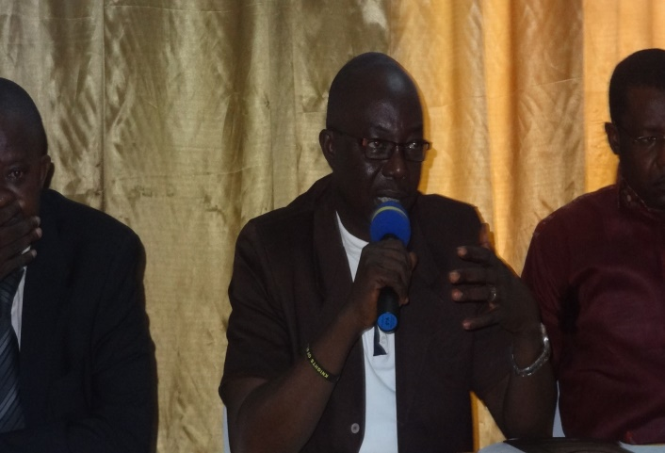
Commissioner - Anthony Koroma
In his statement the Commissioner, National Youth Commission – Anthony Koroma thanked CCYA for the partnership with NAYCOM to organize the consultation. He said it is the responsibility and duty of the Commission to partner with all stakeholders involve in youth development in finding ways and opportunities to advance the issues surrounding key youth development in Sierra Leone.
The Commission views the consultation as timely because the aim is to inputs into the forth coming Africa Union - EU Summit. It is a key summit because in those summits critical decisions are taken, and they can lead to generation of opportunities and mobilization of resources tool to mobilize resources to be able to address critical issues in Sierra Leone.
It is the hope of the National Youth Commission that the quality of representation of key youth leaders and key stakeholders in the youth development will be able to come out with key issues that will inform the position paper that the EU Delegation from sierra Leone will put it together for the EU – Africa Summit. We are here on behalf of the youth of this country to look at the situation and provide recommendations and to also challenge the EU in terms of putting more resources into youth development processes in this country.
Commissioner Koroma further explained that more efforts have been put in place in terms of policy formulation, programs development for youth and there is the need for the country to scale up in building capacity of youth, invest in skills development, and invest in the private sector jobs for labor market. However there is the need to address issues that are confronting young people (violence, misuse of social media and emerging issues). Ending his statement Youth Commissioner thanked the EU Commission for supporting the consultation and appeal to the Union to ensure that resources are directed towards the youth sector.
Ministry of Youth Affairs (MOYA)
The Director of Youth in the Ministry of Youth Affairs – Mr. Charles Moinina, making his statement explained that the ministry is please and to partner with CCYA to hold the one day youth consultation.
Mr. Moinina stated that the Ministry of Youth Affairs is always working in partnership with civil society organizations, NGOs to ensure that youth are given the appropriate directions and programs for their development. MOYA has reviewed the National Youth Policy which is a conduit to address the critical issues confronting the young people of this country. The director said that education is a challenge as many youths could not afford formal education and there is a wide gap between the educated and non-educated. These are the mismatch skills development. Some of the skills acquired by young people are not relevant in the labor market. Youth participation in decision – making is still low even though there has been some progress made at the local level. The Ministry wants to see the participation of youth in program planning and program implementations in all activities directed to youth development in the country.
The director also stated the country is challenged with the issue of migration of our youth to other countries in search of greener pastures. Youth violence and lawlessness is on the rampage as many youth come in conflict with the law and are been sent to correctional centres. Looking at Youth Entrepreneurship is one the recommendations in addressing youth unemployment and empowerment. He urged young people to come up with innovations and become job creators and not just job seekers.

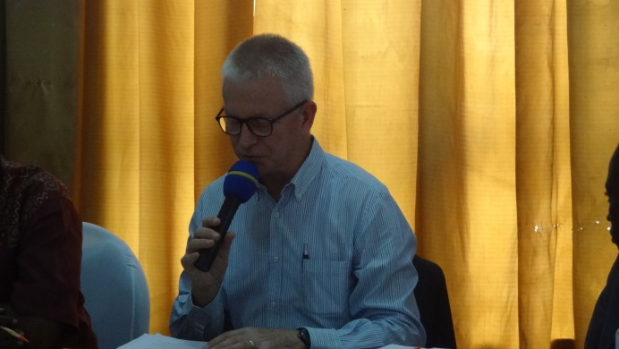
Guest Speaker and Official Opening of the Consultation
Giving keynote statement, the European Union Commission – HE. Ambassador Peter Vasteeg expressed that it’s a privilege for him to address the one day national youth consultation on behalf of the European Union aimed at promoting engagement and investment in youth to enhance peace and security in Sierra Leone.
AmbassadorPeter Vasteeg
Head of EU Delegation in Sierra Leone
He further stated that the long standing partnership with Africa continues to be an important part of EU’s global vision. The EU High Representative Federica Mogherini recently noted that in the world of today full of uncertainties and unpredictability, the African Union and European Union can be forces for good, for our citizens, in particularly our youth, investing in sustainable development, peace and security, multilateralism.
Ambassador Vasteeg highlighted specific actions dedicated to the inclusion and empowerment of youth. Some of which are; EU enhanced partnership with Africa on Peace and Security and job creation for youth on the 4th of May 2017. Also the 4th Africa-Europe Youth Summit will be held from 2-4 October in Abidjan, Ivory Coast and will bring together more than 120 youth leaders from both continents including African Diaspora. The youth summit will result in a declaration on themes including education, peace& security, environment, business, democratic inclusion and culture.
The Ambassador confirmed that a follow-up initiative, “youth plug-in initiative” will take declaration and work between October 30th to November 29th to develop projects to advance the AU-EU Summit on November 29-30 in Abidjan which will be focused on youth. The African and European youth today are faced with many common challenges such as poverty and limited access to resources, education, healthcare and employment, along with social discrimination, lack of participation in decision-making, peace building and conflict resolution processes. The forthcoming summit and plug-in initiative will strengthen the direct participation in the political dialogues that shape our present reality and future outcomes.
In his concluding statement, the EU Ambassador confirmed the EU plans to accompany Africa’s transformation through industrialization (Agenda 2063) through creating more and better jobs, especially for youth, focusing on increasing labor productivity and quality investments in value adding labor intensive sectors, particularly in the agric-food sector. The EU also plans to launch and African Youth Facility to expand the scope of the Erasmus+ programme in areas of youth empowerment and young entrepreneurs, vocational education and training mobility.
National Youth Council of Sierra Leone (NYC-SL)
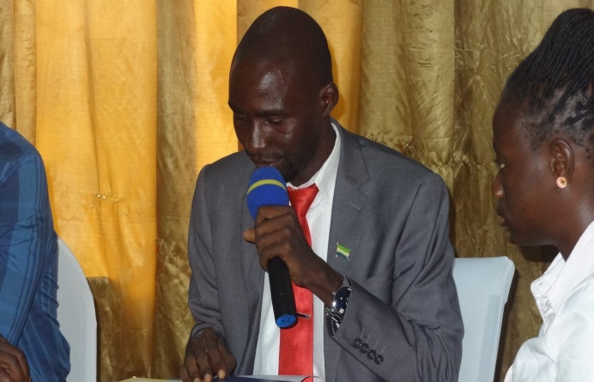
The chairman of the National Youth Council – Mr. Prince Tholey thanked CCYA, MOYA and NAYCOM to have given them the young leaders from across the country representing the majority young people out there in this consultation. He encouraged participants to come out with strong recommendations that will inform a position paper which will speak on behalf of the over 1.7 million young people in the country. He said sometimes youths are seen as tools where they are been called upon when they are needed and be used. He said in many occasion Youth lack the confidence in state institutions as to the manner in which they addressed youth issues. Chairman Tholley said youth leaders are in this conference to make recommendations. He said in terms of participation, NGOs and MDAs have identified the lack of constructive engagement between youth and the state. It is an opportunity for youth today to honestly guide what is supposed to be the next position of Sierra Leone in AU-EU Summit in November. Youth need to come up with recommendations that are affecting young people in Sierra Leone.
Search for Common Ground (SFCG)
The Country Director Search for Common Ground Mr. Joseph Jimmy Sankaituah stated that the EU has provided the youth the opportunity to make their voices heard in the coming AU-EU Summit in November. He encouraged youth leaders that come from other parts of the country representing their respective districts to realize they were representing thousands of their peers. The youth leaders should be thinking about the types of questions they will be asking or issues discussed in the summit. The country director hoped that the discussion in the conference will be useful.
Mr. Sankaituah emphasized on the quality of the discussion and the quality of inputs that should represent the views of youth in Sierra Leone at the AU-EU Summit in November. Ending his statement country director urged all participants to pay attention in the discussion.
1.6. Presentations
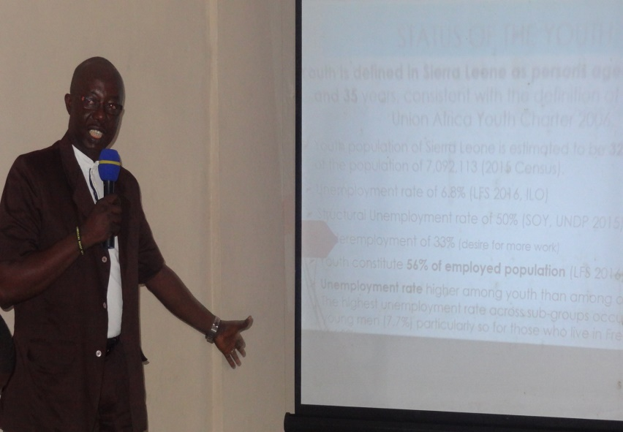
Following a brief presentation on Youth Empowerment and Employment in Sierra Leone; the status, challenges and prospect in the conference, the Commissioner National Youth Commission gave the outline on introduction, country context, and status of youth, challenges, prospect and opportunities.
Facilitator - Anthony Koroma
Highlighting the status of youth in the country the commission stated the following
- Youth population of Sierra Leone is estimated to be 32% (2,269,476) of the population of 7,092,113 (2015 Census).
- Unemployment rate of 6.8% (LFS 2016, ILO)
- Structural Unemployment rate of 50% (SOY, UNDP 2015)
- Underemployment of 33% (desire for more work)
- Youth constitute 56% of employed population (LFS 2016)
- Unemployment rate higher among youth than among older people The highest unemployment rate across sub-groups occurs among young men (7.7%) particularly so for those who live in Freetown (14,0%)

He also through light on some of the most important challenges to youth employment in Sierra Leone are Labour market segmentation, poor education and low skills.
- The majority of unemployed youth are poorly educated and lack relevant and high quality skills to join the labour market or engage in gainful self-employment (nearly 55% of working age population never attended school);
- Current youth employment initiatives have insufficient coordination, and they deliver skills that are mostly not directly creating jobs;
- A struggling and relatively small private sector dominated by FDI’s in large enterprises operating in extractive industries and agriculture.
- Private sector characterized by high level of informality (90% of Laborers work in the informal sector)
In addressing prospect and opportunities for youth employment, which is a topical subject in development circles in Sierra Leone, requires substantially more policy priority by the government of Sierra Leone and the international community. These are;
- The country has been making important strides toward improving youth employment outcomes.
- In 2014, the Government, with the support of the World Bank, UNDP, UNFPA, PLAN International, etc adopted a revised National Youth Policy which outlines the Government’s priority areas of intervention and key strategies for youth empowerment.
- A National Youth Development Programme developed: A Blue Print for Youth Development Programme 2014-2018 to implement the priority areas of the policy.
- Institutional Response: Establishment of the Ministry of Youth Affairs (MOYA) as a policy lead; the National Youth Commission (NAYCOM), which is the youth development project implementing agency; District and National Youth Councils; the National Youth Service and the Budgetary provision for Local councils to address youth development issues
- Macroeconomic policy and programme frameworks: Poverty Reduction Strategy known as the "Agenda for Prosperity (A4P)" defines the overall development of the country and is the main national anchor for dealing with the medium to long-term challenges. The A4P includes a Labor and Employment Pillar
- The President’s Post-Ebola Recovery Priority Plan mainstream youth empowerment as a cross-cutting theme

A full detail of the presentation is attached as an annex to this report (see Annex B)
1.7. Plenary/Group Discussion
During the plenary and group discussions, participants were divided into four groups to discuss on four key broad areas. These are as follows;
- Status of the Youth generally
- What Opportunities exist?
- Challenges and Barriers to Youth Empowerment employment
- Identify concrete steps that can be taken identifying the key players that is GOSL, Youth Serving Agencies, Youth Leaders/Groups) International Organizations.
Some of the outcomes were as follows;
General Status of Youths in Sierra Leone.
- The status of youths in the past:
- Wrong or negative perception about young people in developmental processes.
- Less participation of youths in governance in Sierra Leone.
- Low awareness on statutory documents that governed or concerned the youths.
The current status of youths is thus:
- Drugs and crime (Youths violence et al).
- Petty Trading.
- Prostitution among young girls is in high rate.
- Teenage Pregnancy and Early Marriage.
- Skills Mismatched (Education- formal and non-formal).
Existing opportunities
Are there opportunities? Yes
- Revised National youth policy 2014
- National youth commission
- National youth council
- The African youth charter
- Youth serving agencies
- Civil society organizations
Challenges
- Low budgetary allocation to youth development initiatives/activities
- Lack of effective capacity building mechanism within MDA’s and CSO’s towards youth empowerment.
- Lack of proper coordination amongst youth sector players
- Challenges faced in regards to education for people living with disabilities.
A full detail of the plenary is attached as an annex to this report (see Annex C)
1.8. Action Point/Way forward
- Further engagement of district level on the outcome
- Setting up a communication platform (WhatsApp) to pass on relevant information
- Youth Employment Policy for both youth and private sector
- Radio discussion of community level
- Donor commitment
- Support to Youth Entrepreneurship and skills development through TVET.

@ Adoption of the African Youth Development Fund by the Heads of State and Government of the African Union with US $ 7 million (1% of the budget of the African Union)

ANNEXES:
- Group Work:
Group one (1) Presentation:
Topic: General Status of Youths in Sierra Leone.
- The status of youths in the past:
- Wrong or negative perception about young people in developmental processes.
- Less participation of youths in governance in Sierra Leone.
- Low awareness on statutory documents that governed or concerned the youths.
- Less participation of women in decision making processes at all levels.

- The current status of youths are thus:
- Drugs and crime (Youths violence et al).
- Petty Trading.
- Prostitution among young girls is in high rate.
- Teenage Pregnancy and Early Marriage.
- Skills Mismatched (Education- formal and non-formal).
- Illegal migration (Temple run).
- Low participation of youths in the Agricultural sector.
- Low employment rate amongst youths.
- Intimidation of youths in certain position of trust.
- Huge gap between mainstream and marginalized youths.

- Future status of youths in Sierra Leone are thus:
- Youths should be well empowered with information and involvement in decision making at all level.
- Create more job opportunities for youths.
- Establish more technical vocational centers with the required materials and trained tutors for young people across Sierra Leone.
- Support more young people with micro-finance grants for entrepreneurship purposes.
- Equip both secondary and tertiary institutions with the required teaching and learning materials/equipments needed.
GROUP (Two) 2 Presentation
Existing opportunities
- Revised National youth policy 2014
- National youth commission
- National youth council
- The African youth charter
- Youth Service Agencies
- Civil society organizations
- Ministry of youth affairs other line MDA’s
- National labour acts
- The incorporation of youth into governance
Challenges
- Low budgetary allocation to youth development initiatives/activities
- Lack of effective capacity building mechanism within MDA’s and CSO’s towards youth empowerment.
- Lack of proper coordination amongst youth sector players
- Challenges faced in regards to education for people living with disabilities.
- Lack of soft loans facility for youths
- Lack of youth employment policy
- Regional and political identity
CHALLENGES
Low participation of youths in Governance.
- The youth’s institution that has been setup by Government is not fully capacitated. E.g. the District Youth Council and NAYCOM National Youth Council.
- Negative perception of the MDA’s and the Private Sectors about the youth.
- Policies formulated for youth’s development are not fully implemented.
- Lack of Education and Skills training for youth in the Labor market.
- Inadequate learning facilities.
- The present system of education causes a high rate of drop out from Schools and Universities or Colleges.
- Lack of Youths friendly centers.

BARRIERS
- Lack of Trust and Confident from the MDA’s/Private sector.
- Lack of functional TVET in the Curriculum in the education sector.
- Job Experience.
- Lack of Capital.
- Cancelling on educational issues.
- IDENTIFY CONCRETE STEPS THAT CAN BE TAKEN: (IDENTIFYING THE KEY PLAYERS I.E GOSL, YOUTH SERVING AGENCIES, YOUTH LEADERS/GROUPS, INTERNATIONAL ORGANIZATIONS).
- Skills development in relation to the current job market:
- Building quality and need based Vocational Training centers with qualified tutors and required equipment across the country, that are also charged with the responsibility of linking graduates to the market.
- The existing Sierra Leone Granting Aid scheme should be scaled up and extended to TVET in order to support young people who are willing and capable to be empowered in skills and formal professional courses (i.e. Medicine, Law, Mass Communication, Teaching etc.), that are need based to society by creating an independent local scholarship scheme, that is bias free, but merit based.

ACTORS/KEY PLAYERS
- The private sector
- Government of Sierra Leone through the responsible Ministries Departments and Agencies (MDA)
- Youth Serving Agencies
- The National Youth Council (NYC-SL) and its decentralized structures
- Civil Society Organizations (CSOs)
- UN Agencies and International Non-Governmental Organizations
- European Union
- World Bank, Africa Development Bank, Islamic Development Bank
- Tertiary Institutions should work in collaboration with relevant MDAs (Ministry of Education Science and Technology, Ministry of Youths, NAYCOM, NYC-SL, Ministry of Labor, etc.) to consult with Universities and Colleges across the world that are offering courses of essence in the 21st century, possibly by reviewing and expanding the tertiary educational curriculum to necessary fields of study.
- Provide micro finance support for youths in the agricultural sector, entrepreneur and innovators with coordination from the youth sector (MOYA, NAYCOM and NYC-SL). For this reason, young people should be supported on; Agricultural activities and entrepreneurship.
- Set up well equipped science and technology labs for young innovators and young people in the sciences to match with the current technology trends.
- All youth related programs and projects in the country should be coordinated/championed by the youth sector with the relevant MDAs.
- Youth serving agencies and MDAs should involve young people in the writing/development of youth centered programmes in order to reflect the actual needs of young people and to ensure sustainable development.
- Youth-Led organizations should be supported with grants to take the lead in putting together and implementing youth-focused programmes in collaboration with the youth sector.
- Civic education should be key in changing the mindsets of young people
- Government and donors should lay more emphases on monitoring and evaluation of youth related projects and programs to ensure reaching the right beneficiaries in a greater percentage as required.
- Overview of the Consultation

- Main Presentation: Youth Empowerment and Employment: Status, Challenges and Prospects

- Final Declaration: African Union – European Summit: Consulting Youth in Sierra Leone

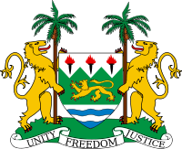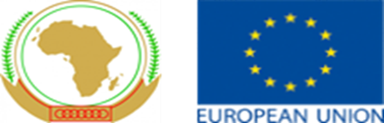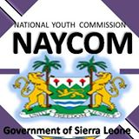
African Union – European Summit: Consulting Youth in Sierra Leone
19th July 2017, Kona Lodge, Freetown
FINAL DECLARATION
BACKGROUND:
The Centre for the Coordination of Youth Activities (CCYA) in collaboration with the Ministry of Youth Affairs (MOYA) and National Youth Commission (NAYCOM) organized a one day national youth consultative conference on the 5th EU-Africa Summit that is scheduled to take place in Ivory Coast on the 28th-29th November 2017 with the theme “YOUTH”.
The conference, held on Wednesday 19th July 2017, at Kona Lodge, Freetown, brought together over 75 young people aged 18 – 35 years from District Youth Councils, National Youth Council, youth leaders from Organizations and civil societies, MDAs and the media from the fourteen districts in Sierra Leone. The one day national youth consultative conference was funded by the European Union Commission in Sierra Leone for which we are extend our appreciations.
Sierra Leone was on an encouraging growth trajectory between 2005 and 2013 when it endured severe traumatic event the widespread Ebola Virus Disease (EVD) outbreak (May 2014 – November 2015). This epidemic killed over 11,000 across West Africa with over 3,500 deaths in Sierra Leone alone. Then an economic shock due to falling prices of iron ore (loss of thousands of jobs) GDP Growth rate was 15.2% in 2012 and plunged to -21.1% in 2015.
Sierra Leone defines Youth as persons aged between 15 and 35 years, consistent with the definition of the African Union Youth Charter 2006. The Youth population of Sierra Leone is estimated to be 32% (2,269,476) of the population of 7,092,113 (2015 Census). Unemployment rate of 6.8% (LFS 2016, ILO) and Structural Unemployment rate of 50% (SOY, UNDP 2015), Underemployment of 33% (desire for more work), Youth constitute 56% of employed population (LFS 2016). But the Unemployment rate is higher among youth than among older people. The highest unemployment rate across sub-groups occurs among young men (7.7%) particularly so for those who live in Freetown (14, 0%). There are high levels of migration (internal and external) and 38% of youth (15-35) live in urban areas (SLIHS 2014).
The high level of youth bulge and Unemployment rate in the Urban areas has exposed youth to serious social vices such as prostitution, Drug, Substance abuse and Ignorance, violence, Sexual Transmitted diseases, HIV/AIDS, Poverty, Lack of Skills and Illiteracy, etc.
CHALLENGES OF YOUTH EMPLOYMENT AND EMPOWERMENT:
The most important challenges to youth employment in Sierra Leone are the Labour market segmentation, poor education and low skills. The majority of unemployed youth is poorly educated and lack relevant and high quality skills to join the labour market or engage in gainful self-employment (nearly 55% of working age population never attended school).
Also the current youth employment initiatives have insufficient coordination, and they deliver skills that are mostly not directly creating jobs.
A struggling and relatively small private sector dominated by Foreign Direct Investments in large enterprises operating in extractive industries and agriculture. Much of the Private sector is characterized by high level of informality (90% of Labourers work in the informal sector).
There is a poor Entrepreneurship culture and lack of access to targeted business development services that include: - access to information technology.
There is Limited or no access to credit facilities, especially the appropriate types such as micro-finance.
The education system has undue emphasis on theory and certification rather than on skills acquisition and proficiency testing. The quality of training offered by the education system from junior, senior secondary school and to tertiary education is inadequate or poor.
There is Low investment in Technical Vocational Education and training TVET in Sierra Leone (2.7% of education expenditure).
RECOMMENDATIONS:
- To improve on Youth Unemployment coordination in Sierra Leone the European Union should support the National Youth Commission and Ministry of Youth Affairs to develop a sector wide approach policy and plan of action. Support should be provided for the implementation of the policy and plan of action.
- We, youth of Sierra Leone, implore policy makers to develop meaningful mechanisms for youth participation and leadership in decision and policy-making from the local to national and international levels. We must also foster young people’s leadership skills, creating an interdependent virtuous cycle to shift the negative perceptions and discourse on young people to that of partners in building peaceful and sustainable communities.
- Youth employment, is a topical subject in development circles in Sierra Leone, requires substantially more policy priority by the government of Sierra Leone and the international community, especially the European Union.
- Recognizing that youth should actively be engaged in shaping lasting peace and contributing to justice and reconciliation, and that a large youth population presents a unique demographic dividend that can contribute to lasting peace and economic prosperity if inclusive policies are in place.
- Point out that the difficulties that such large numbers of young people encounter in finding decent jobs could become a source of social and political instability and require a comprehensive approach to provide TVET and start up support to entrepreneurships. Therefore call for the employment issue, particularly youth employment, to be included in the priorities for cooperation between Europe and Africa.
- Underline the importance of securing inclusive economic growth, also by capitalizing on the opportunities offered by a solidarity-based, social economy. In this connection, they would urge that the economic growth model prevailing in Africa for many years, to a great extent based on the export of raw materials such as minerals, hydrocarbons and agricultural products shift towards the introduction of value added in order to create more decent jobs for the youth in Sierra Leone.
- For quality and affordable education to be realized, that every Sierra Leone guarantee universal basic education and give priority to improving the vocational training system. Synergies between the education system and the labour market also need to be created. Partnerships between businesses and educational and training establishments ought to be strengthened when preparing Programmes and anticipating needs. Given the importance of agriculture for employment, specific vocational training Programmes aimed at young farmers, as part of integrated rural development policies, should be stepped up with support from the European Union.

